** A**

**Project Report**

on

**Exploring the Potential of Augmented Reality Technology for Comprehensive and In-Depth Human Anatomy Learning**

**AR Anatomy**

submitted as partial fulfillment for the award of

**BACHELOR OF TECHNOLOGY**

**DEGREE**

SESSION 2024-25

in

**Computer Science and Engineering**

By

Shahnawaz (2100290100153)

**Under the supervision of**

Dr. Ankur Bhardwaj

**KIET Group of Institutions, Ghaziabad**

Affiliated to

**Dr. A.P.J. Abdul Kalam Technical University, Lucknow**

(Formerly UPTU)

**May, 2025**

**DECLARATION**

We hereby declare that this submission is our own work and that, to the best of our knowledge and belief, it contains no material previously published or written by another person nor material which to a substantial extent has been accepted for the award of any other degree or diploma of the university or other institute of higher learning, except where due acknowledgment has been made in the text.

Signature

Name: Shahnawaz

Roll No.: 2100290100153

Date:

## CERTIFICATE

This is to certify that Project Report entitled **“Exploring the Potential of Augmented Reality Technology for Comprehensive and In-Depth Human Anatomy”** which is submitted by **Shahnawaz** in partial fulfillment of the requirement for the award of degree B. Tech. in Department of Computer Science & Engineering of Dr. A.P.J. Abdul Kalam Technical University, Lucknow is a record of the candidates own work carried out by them under my supervision. The matter embodied in this report is original and has not been submitted for the award of any other degree.

**Dr. Ankur Bhardwaj** **Dr. Vineet Sharma**

**(Associate Professor)** **(Dean CSE)**

**Date:**

ACKNOWLEDGEMENT

It gives us a great sense of pleasure to present the report of the B. Tech Project undertaken during B. Tech. Final Year. We owe special debt of gratitude to Dr. Ankur Bhardwaj, Department of Computer Science & Engineering, KIET, Ghaziabad, for his constant support and guidance throughout the course of our work. His sincerity, thoroughness and perseverance have been a constant source of inspiration for us. It is only his cognizant efforts that our endeavors have seen light of the day.

We also take the opportunity to acknowledge the contribution of Dr. Vineet Sharma, Dean CSE, KIET, Ghaziabad, for his full support and assistance during the development of the project. We also do not like to miss the opportunity to acknowledge the contribution of all the faculty members of the department for their kind assistance and cooperation during the development of our project.

We also do not like to miss the opportunity to acknowledge the contribution of all faculty members, especially faculty/industry person/any person, of the department for their kind assistance and cooperation during the development of our project. Last but not the least, we acknowledge our friends for their contribution in the completion of the project.

Date:

Signature:

Name : Shahnawaz

Roll No.: 2100290100153

ABSTRACT

Human anatomy education has long been a crucial part of medical and life sciences, requiring learners to develop an in-depth understanding of complex spatial relationships. Traditional methods, including cadaveric dissections and anatomical models, while effective, face limitations such as accessibility constraints and ethical considerations. Augmented Reality (AR) has emerged as a transformative technology that addresses these challenges by offering interactive, three-dimensional visualization of anatomical structures. This project explores the integration of AR in anatomy education, examining its effectiveness, usability, and pedagogical implications. By overlaying digital information onto real-world settings, AR enhances spatial understanding, engagement, and knowledge retention. This report presents a detailed analysis of AR’s advantages, challenges, and potential future applications in the field of anatomy education. Additionally, it highlights the emerging trends in AR implementation, discussing various case studies, user feedback, and expert insights into how AR can bridge existing educational gaps. The research incorporates both qualitative and quantitative assessments to ensure a comprehensive evaluation of the technology's impact on anatomy learning.

|  |  |
| --- | --- |
| **TABLE OF CONTENTS** | **Page No.** |
| DECLARATION……………………………………………………………………. | ii |
| CERTIFICATE……………………………………………………………………… | iii |
| ACKNOWLEDGEMENTS…………………………………………………………. | iv |
| ABSTRACT……………………………………………………………………….... | v |
| LIST OF FIGURES…………………………………………………………………. | viii |
| LIST OF TABLES…………………………………………………………………. | ix |
| LIST OF ABBREVIATIONS………………………………………………………. | x |
| CHAPTER 1 (INTRODUCTION)…………………………………………………. | 1 |
| 1.1. Introduction…………………………………………………………………... | 1 |
| 1.2. Historical context of anatomy education…….................................................... | 2 |
| CHAPTER 2 (LITERATURE RIVIEW) …………………………………………. | 3 |
| 2.1. Historical Context.…………............................................................................. | 3 |
| 2.2. Benefits of AR in Anatomy Education .............................................................. | 4 |
| 2.3. Comparative Studies and Meta-Analysis ........................................................... | 6 |
| 2.4. Emerging Trends in AR and Education ............................................................. | 7 |
|  |  |
| CHAPTER 3 (PROPOSED METHODOLOGY) ….................................................. | 10 |
| 3.1. Research Approach............................................................................................... | 10 |
| 3.2. Data Collection…................................................................................................ | 11 |
| 3.3. Tools for Data Analysis........................................................................................ | 12 |
| 3.4. Implementation Strategy....................................................................................... | 13 |
| 3.5. System Design and User Testing ......................................................................... | 22 |
| CHAPTER 4 (RESULTS AND DISCUSSION) ........................................................ | 27 |
| 4.1. Comparative Analysis of AR vs. Traditional....................................................... | 27 |
| 4.2. Effectiveness of AR in Spatial Understanding.................................................... | 30 |
| 4.3. Engagement and Knowledge Retention............................................................... | 31 |
| 4.4. User Feedback and Practical Application............................................................. | 31 |
| CHAPTER 5 (CONCLUSION AND FUTURE SCOPE) .......................................... | 32 |
| 5.1. Conclusion …………………………………....................................................... | 32 |
| 5.2. Future Scope and Potential Enhancements…....................................................... | 33 |
|  |  |
| REFERENCES………………………………………………………………………. | 59 |
| APPENDEX-I: Plagiarism Report ……….………………………………………….. | 60 |
|  |  |
|  |  |
|  |  |
|  |  |
|  |  |
|  |  |
|  |  |
|  |  |

**LIST OF FIGURES**

|  |  |  |
| --- | --- | --- |
| **Figure No.** | **Description** | **Page No.** |
| 2.2 | Showing AR devices | 24 |
| 3.1 | User testing screenshots: placing the model | 36 |
| 3.2 | User testing screenshots: exploring the features | 37 |
| 3.3 | Other available models | 38 |
| 4.1 | Anonymous questionnaire six-item Likert scale | 44 |

**LIST OF TABLES**

|  |  |  |
| --- | --- | --- |
| **Table. No.** | **Description** | **Page No.** |
| 2.1 | Comparative Overview of Learning Tools in Anatomy Education | 21-23 |

**LIST OF ABBREVIATIONS**

AR Augmented Reality

VR Virtual Reality

XR Extended Reality

3D 3-Dimension

AI Artificial Intelligence

LMS Learning model skill

EHR Electronic health records

ANOVA analysis of variance

SUS System Usability Scale

NASA-TLX National Aeronautics and Space Administration Task Load Index

2D 2-Dimension

SPSS Statistical Package for the Social Sciences

MATLAB Matrix laboratory

MVP Minimum viable product

UI User interface

UX User experience

**CHAPTER 1**

**INTRODUCTION**

**1.1 INTRODUCTION**

The adoption of Augmented Reality (AR) in education has seen rapid growth in recent years, driven by its ability to transform traditional learning methods into more interactive, engaging, and immersive experiences. AR technology, which overlays digital content onto the real world, offers a revolutionary approach to education by blending virtual elements with physical environments, creating a hybrid learning space that enhances comprehension and retention. The acceleration of AR adoption in educational contexts can be attributed to several key factors that address longstanding challenges in traditional pedagogical approaches.

AR offers greater accessibility by allowing students to access educational content remotely, breaking down geographical barriers and democratizing high-quality educational experiences. Students in remote or underserved areas can now interact with sophisticated learning materials that were previously available only in well-resourced institutions. This accessibility extends to learners with mobility limitations who might find traditional laboratory environments challenging to navigate. Through AR applications on widely available devices like smartphones and tablets, educational content becomes portable and available anytime, anywhere, significantly expanding the reach of specialized instruction.

The cost-effectiveness of AR technology also makes it an appealing alternative for educational institutions, particularly in fields where traditional learning resources are expensive, limited, or difficult to maintain. AR can reduce dependence on costly physical resources—such as cadavers in medical training, complex laboratory equipment in science education, or rare artifacts in humanities studies—while still providing high-quality educational experiences. For example, medical schools can supplement their limited cadaver resources with AR applications that allow unlimited virtual dissections without ongoing maintenance costs or ethical concerns. Similarly, chemistry departments can simulate dangerous or expensive experiments through AR, reducing costs associated with laboratory supplies and safety equipment while still offering hands-on learning experiences.

Furthermore, advancements in AR technology have accelerated its adoption in educational environments. The development of more intuitive applications with user-friendly interfaces has removed many of the technical barriers that previously limited AR implementation. Modern AR platforms require minimal technical expertise to operate, allowing educators to focus on content delivery rather than troubleshooting. Simultaneously, the hardware required to support AR experiences has become more affordable and accessible. The proliferation of AR-capable smartphones and tablets, coupled with decreasing costs of dedicated AR headsets, has made implementation financially feasible for many institutions. These technological improvements have created a positive feedback loop, where increased adoption drives further investment in AR development, resulting in even more sophisticated and accessible educational applications.

In the specific field of medical education, AR has proven particularly valuable for complex subjects like human anatomy, where traditional learning methods often struggle to convey spatial relationships and three-dimensional structures effectively. Interactive 3D models accessible through AR help students better grasp complex anatomical structures and spatial relationships that are difficult to comprehend through two-dimensional illustrations or even physical models. For instance, AR applications can demonstrate the dynamic relationship between the heart's chambers and valves during different phases of the cardiac cycle—a concept that static images cannot adequately represent. These interactive visualizations allow students to explore anatomical structures from multiple angles, peel away layers to examine internal components, and even animate physiological processes to understand functional relationships.

**1.2 HISTORICAL CONTEXT OF ANATOMY EDUCATION**

Human anatomy education has long depended on traditional methods such as cadaveric dissections, anatomical atlases, and physical models. These approaches have played a vital role in building foundational knowledge and offering direct, hands-on experience to students for centuries. Cadaveric dissection, dating back to ancient civilizations but formalized in medical education during the Renaissance period, has been considered the gold standard for anatomy learning due to its authenticity and tactile experience. Anatomical atlases, pioneered by works such as Vesalius's "De Humani Corporis Fabrica" in the 16th century, have provided detailed visual references for generations of medical students. Physical models, which gained prominence in the 19th and 20th centuries, have offered durable, standardized representations of human structures that can be handled and examined repeatedly.

However, despite their historical importance and continued relevance, these traditional approaches also present several longstanding challenges that have persisted throughout the evolution of medical education. Limited accessibility remains a significant issue, as high-quality cadavers, detailed atlases, and accurate models may not be equally available across different educational settings, particularly in resource-constrained environments or developing regions. The distribution of these resources often follows patterns of economic disparity, creating inequities in educational quality and opportunities.

Traditional methods also impose high resource demands on educational institutions. The procurement, preservation, storage, and proper disposal of cadavers require specialized facilities, trained staff, and ongoing maintenance—all of which translate to substantial financial investments. Similarly, comprehensive anatomical atlases and precise physical models can be prohibitively expensive, especially when institutions need multiple copies or sets to accommodate large student populations. These economic barriers often force compromises in the quality or quantity of educational resources available to students.

Ethical considerations further complicate the landscape of anatomy education, particularly regarding cadaveric dissection. Cultural and religious perspectives on death and the treatment of human remains vary widely, creating potential conflicts for students from diverse backgrounds. Questions surrounding consent, dignity, and respectful handling of donated bodies add layers of ethical complexity that educators must navigate. Additionally, the psychological impact of working with cadavers can be significant for some students, potentially creating barriers to learning or necessitating additional support systems.

Perhaps most significantly from a pedagogical perspective, traditional methods often present difficulties in visualizing complex spatial relationships within the human body. Two-dimensional atlases, while detailed, cannot fully convey the three-dimensional nature of anatomical structures and their interconnections. Physical models, though three-dimensional, are frequently simplified or segmented, making it challenging to understand how individual components relate to the whole. Even cadaveric dissection, despite its authenticity, presents structures that may be altered by preservation methods, age-related changes, or pathological conditions—potentially creating misconceptions about normal anatomy in living individuals.

As educational needs evolve in response to changing healthcare practices, technological capabilities, and student demographics, there is a growing emphasis on incorporating technological innovations to enhance learning outcomes. Modern medical practice increasingly relies on imaging technologies and digital visualizations, creating a need for educational approaches that prepare students for this digitally-mediated clinical environment. Additionally, today's students—often digital natives—have different learning preferences and expectations than previous generations, favoring interactive, multimedia approaches over traditional text-based or static learning resources.

Among the various technological innovations being explored in anatomy education, Augmented Reality (AR) has emerged as a particularly promising tool due to its unique ability to bridge physical and digital learning environments. By blending digital content with the physical environment, AR offers new possibilities for interactive, engaging, and immersive learning experiences that can complement and, in some cases, transform traditional anatomy education. Unlike purely virtual approaches, AR maintains a connection to the physical world, allowing integration with existing educational resources such as textbooks, laboratory spaces, or even cadaveric specimens—creating a hybrid learning environment that leverages the strengths of both traditional and digital approaches.

**1.3 PROJECT DESCRIPTION**

This project, titled "Exploring the Potential of Augmented Reality Technology for Comprehensive and In-Depth Human Anatomy Learning," is focused on the development of an immersive AR-based educational platform designed to transform the way students engage with human anatomy. The project represents a significant interdisciplinary effort, combining expertise in medical education, software development, instructional design, and user experience research to create a tool that addresses the limitations of traditional anatomy teaching methods while leveraging the unique capabilities of modern AR technology.

At its core, the platform will enable learners to visualize and interact with three-dimensional anatomical models in a dynamic and intuitive environment. Unlike static illustrations or physical models, these digital representations will be fully manipulable, allowing users to rotate, zoom, dissect, and explore anatomical structures from any angle or perspective. This capability directly addresses one of the most significant challenges in anatomy education: the development of accurate mental models of three-dimensional structures from two-dimensional learning materials.

The AR application will be designed with a layered approach to anatomical visualization, enabling students to progressively reveal or hide different bodily systems and structures. For example, users can begin by examining superficial muscular structures, then gradually peel away layers to reveal underlying vasculature, nerves, and organs, finally reaching the skeletal system—all while maintaining a clear understanding of the spatial relationships between these elements. This sequential exploration mirrors the actual process of dissection but offers the advantages of reversibility, repeatability, and precision that physical dissection cannot provide.

By allowing users to manipulate structures and examine anatomical components from multiple angles, the application aims to improve spatial awareness and conceptual understanding of the human body. Students will be able to view structures in isolation or in context, helping them grasp both the unique characteristics of individual components and their functional relationships within larger systems. For instance, a student studying the heart can examine its external features, then look inside to understand the chambers and valves, while also visualizing its position relative to surrounding organs, ribs, and the diaphragm—all within a single, continuous learning experience.

Through these interactive AR experiences, students can explore the intricacies of bodily systems and functions in a more accessible and engaging manner than traditional methods typically allow. The platform will include detailed visualizations of all major body systems, including cardiovascular, respiratory, digestive, nervous, musculoskeletal, reproductive, and lymphatic systems. Each system will be accompanied by comprehensive anatomical labeling, functional descriptions, and relevant clinical correlations that highlight the practical importance of specific structures or relationships.

Features such as virtual dissections, real-time feedback, and gamified learning elements are incorporated to sustain interest and promote active learning. Virtual dissection tools will allow students to make precise digital "incisions" and remove or separate structures with a degree of control impossible in physical dissection. Real-time feedback mechanisms will provide immediate guidance and information as students interact with the models, helping to correct misconceptions and reinforce accurate understanding. Gamified elements—such as identification challenges, anatomical puzzles, and progress tracking—will capitalize on principles of engagement and motivation from educational game design to encourage continued exploration and practice.

The learning experience will be further enhanced through integration with evidence-based educational methodologies. For example, the platform will incorporate spaced repetition techniques by prompting users to revisit previously studied structures at optimal intervals for long-term retention. Contextual learning principles will be applied by presenting anatomical information alongside relevant physiological processes, pathological conditions, and clinical scenarios—helping students understand not just the "what" but also the "why" of anatomical structures.

Furthermore, the platform will be designed with user-centric principles, incorporating supportive tools like haptic cues, voice-guided navigation, and adaptive interfaces that accommodate various learning styles and needs. Haptic feedback (subtle vibrations or resistance) will help users "feel" boundaries between structures or indicate important landmarks during exploration. Voice-guided navigation will offer audio descriptions and instructions, supporting auditory learners and providing an additional information channel during visual exploration. Adaptive interfaces will respond to individual user patterns and preferences, customizing the learning experience to match each student's pace, interests, and areas of difficulty.

For educators, the platform will include administrative tools to monitor student progress, identify common areas of difficulty, and customize content to align with specific curriculum requirements or learning objectives. Integration capabilities with common learning management systems will facilitate seamless incorporation into existing educational frameworks, allowing the AR application to complement rather than compete with established teaching methodologies.

Collectively, this project aspires to create a comprehensive digital anatomy learning environment that bridges the gap between theoretical knowledge and practical comprehension. By combining the spatial fidelity of three-dimensional visualization with the interactivity of modern digital interfaces and the pedagogical structure of thoughtfully designed learning experiences, the platform aims to address the limitations of traditional anatomy education while preparing students for the increasingly digital landscape of modern healthcare. The ultimate goal is not to replace traditional methods entirely but to provide a powerful complementary tool that enhances understanding, engagement, and retention—ultimately producing healthcare professionals with stronger anatomical foundations for clinical practice.

**CHAPTER 2**

**LITERATURE REVIEW**

**2.1 HISTORICAL CONTEXT**

Human anatomy has been a core subject in medical and health sciences education for centuries, with its systematic study dating back to ancient civilizations. In Ancient Egypt (3000 BCE), the process of mummification led to rudimentary understanding of internal organs. The Greeks, particularly through Hippocrates (460-370 BCE) and later Galen (129-210 CE), established more formal anatomical studies, though many of Galen's conclusions were based on animal dissections rather than human bodies. The Renaissance period marked a significant turning point with Andreas Vesalius (1514-1564) publishing "De Humani Corporis Fabrica," which corrected many of Galen's errors through systematic human dissection.

Throughout this rich history, the teaching of anatomy relied heavily on cadaveric dissection, textbook illustrations, two-dimensional anatomical atlases, and static plastic models. These methods have formed the backbone of anatomical instruction in medical schools worldwide and have provided invaluable, hands-on experiences that help students understand the structural complexities of the human body.

**2.1.1 CADAVERIC DISSECTION**

Cadaveric dissection has long been considered the "gold standard" in anatomy education. It allows students to directly observe, touch, and dissect human tissues, providing a realistic understanding of the body's three-dimensional structure and variability. The importance of this method was highlighted by Sir William Osler, who noted that "to study the phenomena of disease without books is to sail an uncharted sea, while to study books without patients is not to go to sea at all." This sentiment equally applies to anatomy education, where theoretical knowledge must be complemented by practical experience.

However, this method has several limitations:

**• Ethical and legal concerns:** The procurement and use of human bodies involve complex ethical considerations regarding consent, dignity, and cultural sensitivity. Different countries have varying regulations on body donation programs, which can limit availability. The Visible Human Project and Body Worlds exhibitions have sparked debates about the ethics of displaying human remains, even for educational purposes.

**• Limited availability of cadavers:** This is especially problematic in developing regions or institutions with fewer resources. For instance, in sub-Saharan Africa, the cadaver-to-student ratio can be as high as 1:500 in some medical schools, compared to the recommended 1:10 ratio. In India, despite having numerous medical colleges, there is an estimated shortage of over 8,000 cadavers annually for teaching purposes.

**• High costs:** Maintenance, storage, and laboratory infrastructure for cadaver programs are expensive. The cost of preserving a single cadaver can range from $2,000 to $3,000 annually, not including the specialized facilities, ventilation systems, and safety equipment required. Smaller institutions often cannot bear these expenses, creating disparities in educational quality.

**• Emotional and psychological discomfort:** Many students experience significant emotional responses when encountering cadavers for the first time. Studies have shown that approximately 30% of medical students report symptoms of stress, anxiety, or sleep disturbances after initial dissection experiences. While this exposure is valuable for developing professional desensitization necessary for clinical practice, it can be traumatic for some students and requires careful preparation and support systems.

**• Formalin exposure concerns:** Traditional preservation methods using formalin pose health risks with prolonged exposure, including respiratory issues and potential carcinogenic effects. While alternative preservation techniques like Thiel embalming offer more realistic tissue texture and reduced toxicity, they are more expensive and less widely adopted.

**2.1.2 ANATOMICAL ATLASES AND TEXTBOOKS**

Anatomical atlases and textbooks offer detailed illustrations and labeled diagrams of the human body, serving as essential visual references for students. Classic works such as Gray's Anatomy (first published in 1858) and Netter's Atlas of Human Anatomy have been cornerstones of anatomical education for generations. Modern editions incorporate radiological images like CT and MRI scans to bridge the gap between illustrated anatomy and clinical imaging.

However, these resources have inherent limitations:

**• Static and two-dimensional representation:** These materials make it difficult to understand complex spatial relationships between anatomical structures. For example, the intricate arrangement of the brachial plexus or the path of cranial nerves through various foramina is challenging to visualize from flat images alone.

**• Lack of individual variation representation:** Standard atlases typically depict idealized anatomical structures, failing to capture the significant variation found in the general population. Studies have shown that anatomical variations, such as aberrant blood vessels or nerve pathways, occur in up to 20% of individuals for certain structures. These variations are critically important in clinical practice, where unexpected anatomy can complicate surgical procedures.

**• Passive learning limitations:** Engagement with texts often results in lower retention and engagement compared to more interactive methods. According to educational research, students typically retain only about 10% of what they read but approximately 75% of what they practice by doing. This significant difference highlights the limitations of text-based learning for a subject that is inherently three-dimensional and complex.

**• Standardization challenges:** Different atlases may use varying terminology or coloring conventions, potentially creating confusion for students using multiple resources. Although the Terminologia Anatomica has standardized nomenclature since 1998, many regional and institutional differences in terminology persist in educational materials.

**2.1.3 PLASTIC MODELS**

Three-dimensional plastic models provide a tactile and visual representation of anatomical structures. They are reusable, safe, and accessible for many institutions. These models range from simple representations of individual organs to complex, life-sized, dissectible human figures with removable parts.

Nonetheless, plastic models have significant limitations:

**• Lack of realistic characteristics:** They lack the realistic texture, color, and variability of human tissues. The uniformity of plastics cannot replicate the subtle differences between fascial planes, the elasticity of blood vessels, or the texture gradations between different tissue types. This simplification can create disconnects when students transition to clinical settings or cadaveric dissection.

**• Fixed nature:** Their fixed nature limits exploration beyond predefined layers or parts. Most models are designed to be separated along standardized planes that may not correspond to surgical approaches or physiological relationships. For example, a model heart may separate into anterior and posterior halves, which does not reflect how a clinician would access the heart during surgery.

**• Inability to simulate physiological processes:** They cannot effectively simulate dynamic physiological processes such as muscle contraction, blood flow, or respiratory movements. This static representation fails to convey the functional aspects of anatomy, which are essential for understanding pathophysiology and clinical manifestations of disease.

**• Durability and maintenance issues:** Over time, models deteriorate with repeated handling, parts can be misplaced, and colors may fade, reducing their educational value. The replacement cost for high-quality anatomical models can be substantial, with comprehensive human torsos ranging from $3,000 to $20,000 depending on detail and functionality.

**• Simplification of complex structures:** Intricate structures like the inner ear, retina, or neural pathways are often oversimplified in plastic models due to manufacturing constraints, potentially leading to conceptual gaps in student understanding.

**2.1.4 TECHNOLOGICAL CONSTRAINTS OF THE PAST**

Before the advent of modern computing and visualization tools, anatomical education faced significant technological limitations:

**• Limited visualization options:** Educators relied primarily on two-dimensional illustrations or physical models, lacking the capability to generate customized views or cross-sections on demand. The dynamic nature of physiological processes could only be approximated through sequential static images or rudimentary animations.

**• Restricted access to rare specimens:** Unusual pathological specimens or rare anatomical variations were accessible only through museum collections at major medical institutions. This centralization limited exposure for students at smaller or remote institutions.

**• Heavy reliance on instructor expertise:** The quality of anatomical education depended heavily on the individual instructor's ability to verbally describe and physically demonstrate concepts that were difficult to visualize. This created inconsistencies in educational experiences across different institutions or even within the same program.

**• Insufficient feedback mechanisms:** Students had limited means to self-assess their understanding or receive immediate feedback on their anatomical knowledge outside of formal laboratory sessions. This delayed feedback loop could allow misconceptions to become entrenched before correction.

**• Standardization challenges:** Before digital distribution of educational content, anatomical education materials varied significantly between institutions, potentially leading to inconsistencies in knowledge and terminology. This posed challenges for students transferring between programs or entering standardized licensing examinations.

**• Rote memorization emphasis:** Students relied heavily on rote memorization and instructor-led demonstrations, which often led to surface-level understanding rather than deep comprehension. The cognitive load of memorizing numerous structures and relationships could overwhelm meaningful conceptual integration.

While traditional methods have been foundational in anatomical education, they are increasingly viewed as incomplete and insufficient for meeting the needs of diverse, modern learners. The limitations in accessibility, interactivity, and adaptability highlight the need for innovative technologies—such as Augmented Reality—that can enhance, complement, or even replace conventional approaches in certain contexts.

**2.2 BENEFITS OF AR IN ANATOMY EDUCATION**

The integration of Augmented Reality (AR) into anatomy education offers a range of benefits that address the limitations of traditional learning methods while significantly enhancing the quality of instruction and comprehension.

**2.2.1 ENHANCED SPATIAL UNDERSTANDING**

One of the most significant advantages of AR is its ability to provide dynamic, three-dimensional visualizations of anatomical structures. Students can rotate, zoom, and dissect virtual models in real-time, allowing for a more intuitive grasp of spatial relationships between organs, tissues, and systems. Unlike static images or plastic models, AR presents anatomy in a way that mirrors real-life complexity and depth, helping learners develop a more accurate mental map of the human body.

This enhanced spatial understanding is particularly valuable for complex anatomical regions such as:

* **The cranial cavity:** AR can demonstrate the intricate relationships between cranial nerves, blood vessels, and brain structures as they pass through various foramina and fissures—relationships that are notoriously difficult to visualize in two dimensions.
* **The mediastinum:** The spatial arrangement of the heart, great vessels, esophagus, and trachea can be explored from multiple angles, with the ability to selectively hide structures to focus on specific relationships.
* **The pelvic region:** The complex three-dimensional arrangement of reproductive, urinary, and digestive structures, along with their neurovascular supply, becomes more comprehensible through interactive exploration.

Research conducted at Stanford University Medical School found that students using AR for studying complex anatomical relationships scored 23% higher on spatial relationship questions compared to those using traditional methods alone. This improvement in spatial cognition has direct implications for clinical skills that require precise anatomical visualization, such as surgical planning, radiological interpretation, and physical examination.

**2.2.2 INCREASED ENGAGEMENT**

AR transforms passive learning into an active experience. By enabling interaction with digital content, AR captures student interest and sustains attention more effectively than traditional lectures or textbook-based learning. The novelty and interactivity of AR environments can stimulate curiosity, making the learning process more enjoyable and immersive. This increased engagement has been linked to improved motivation and academic performance.

Studies have demonstrated the engagement benefits of AR in various educational contexts:

* A 2023 study published in Anatomical Sciences Education found that medical students spent an average of 38% more voluntary study time with AR anatomy applications compared to conventional study materials.
* Attention measurements using eye-tracking technology showed that students maintained focused attention for longer periods (average of 27 minutes versus 18 minutes) when using AR compared to textbook study.
* Self-reported motivation scores were significantly higher (4.2 versus 3.1 on a 5-point scale) among students with access to AR learning tools.

This heightened engagement is particularly beneficial for today's learners, who have grown up in a digital environment and may respond more positively to interactive, technology-enhanced educational methods. The gamification elements often incorporated into AR applications—such as achievement badges, progressive difficulty levels, and competitive elements—further boost motivation and sustained interest in the subject matter.

**2.2.3 REAL-TIME FEEDBACK**

AR platforms offer features that provide immediate feedback as students interact with anatomical models or complete tasks. This supports self-directed learning and enables students to identify and correct mistakes on the spot. Real-time feedback not only reinforces correct knowledge but also helps learners build confidence and autonomy in their studies.

Examples of effective feedback mechanisms in AR anatomy applications include:

* **Color-coded highlighting:** When students attempt to identify structures, correct identifications trigger green highlights while incorrect selections produce red indicators, immediately signaling accuracy.
* **Guided exploration:** If a student seems confused or is exploring inefficiently, the system can provide subtle hints or suggestions to direct attention to relevant areas.
* **Progressive disclosure:** Information is revealed as students successfully master prerequisite concepts, creating a scaffolded learning experience tailored to individual progress.
* **Performance analytics:** Students receive graphical representations of their performance over time, identifying areas of strength and weakness to guide further study.

Research from the University of Toronto demonstrated that students receiving real-time feedback through AR applications showed a 31% improvement in test performance compared to those who received delayed feedback through traditional assessment methods. This immediate reinforcement loop helps solidify correct anatomical knowledge and quickly remediates misconceptions before they become entrenched.

**2.2.4 ACCESSIBILITY**

AR applications are typically compatible with widely available devices such as smartphones, tablets, and AR headsets, making them accessible to a broad range of users. Students can use these tools remotely, outside the traditional classroom or lab, which is especially beneficial for distance learning or institutions with limited physical resources. This flexibility helps bridge geographic and economic gaps in education, promoting equity and inclusion.

The accessibility advantages of AR in anatomy education include:

* **Geographic independence:** Students in remote or rural areas can access high-quality anatomical models without needing to travel to specialized facilities. This is particularly valuable in countries with centralized medical education resources.
* **Schedule flexibility:** Learners can study at times convenient to them, accommodating various personal and professional commitments that might make traditional laboratory hours challenging.
* **Resource equalization:** Institutions with limited budgets for cadavers or expensive physical models can provide high-quality learning experiences through AR, reducing educational disparities.
* **Adaptability for different abilities:** Many AR applications include features that accommodate various learning needs, such as text-to-speech for visually impaired users or simplified interaction models for those with limited dexterity.

A comparative study across medical schools in five countries found that introducing AR anatomy resources significantly reduced the performance gap between well-resourced urban institutions and those in under-resourced areas, with standardized test score differences decreasing from 14% to just 3%.

**2.2.5 IMPROVED LONG-TERM KNOWLEDGE RETENTION**

Research indicates that learning in immersive environments like AR improves memory retention and the ability to apply knowledge in practical contexts. By engaging multiple senses and allowing for hands-on exploration, AR encourages deeper cognitive processing. This leads to better long-term retention of anatomical concepts compared to passive or surface-level learning approaches.

The cognitive mechanisms supporting this improved retention include:

* **Dual coding theory:** AR simultaneously presents visual and verbal information, creating multiple neural pathways for retrieval.
* **Elaborative encoding:** The interactive nature of AR encourages students to make meaningful connections between new information and existing knowledge.
* **Spaced repetition:** Many AR applications incorporate algorithms that present information at optimal intervals for long-term memory formation.
* **Emotional engagement:** The novel and immersive quality of AR creates emotional responses that enhance memory formation and recall.

Longitudinal studies have demonstrated that students who used AR as part of their anatomy education retained 29% more information when tested six months later compared to those who relied solely on traditional methods. This retention advantage holds significant implications for clinical practice, where accurate anatomical knowledge must be readily accessible years after formal education concludes.

Despite the advantages of AR in anatomy education, several challenges persist. High development and maintenance costs remain a barrier, making widespread adoption difficult. Additionally, technical constraints such as device compatibility, latency issues, and the need for high-performance hardware limit the accessibility of AR applications. Another significant challenge is the learning curve associated with AR tools; students and educators unfamiliar with AR technology may require additional training to effectively utilize the platform. Furthermore, the lack of standardized evaluation methods makes it difficult to measure the long-term effectiveness of AR-based learning compared to traditional techniques.

**2.3 COMPARATIVE STUDIES AND META-ANALYSIS**

As educational technologies continue to evolve, a growing body of research has emerged comparing the effectiveness of Augmented Reality (AR) with other modern instructional tools such as Virtual Reality (VR), 3D printing, and simulation-based software. These comparative studies help underscore the unique advantages and situational strengths of each modality, particularly within the context of anatomy education.

**2.3.1 Methodological Considerations in Comparative Research**

Before examining specific findings, it's important to understand the methodological frameworks through which these comparisons are evaluated. Most studies employ one or more of the following assessment approaches:

* **Knowledge acquisition metrics:** Pre- and post-intervention testing to measure factual and conceptual learning gains.
* **Usability evaluations:** Standardized instruments like the System Usability Scale (SUS) that quantify ease of use and user satisfaction.
* **Time efficiency measurements:** Tracking how quickly students master specific learning objectives using different modalities.
* **Transfer of learning assessments:** Evaluating how well knowledge gained through technological interventions applies to clinical scenarios or traditional testing formats.

These varied assessment methods help provide a multidimensional understanding of each technology's strengths and limitations.

**2.3.2 AR vs. Virtual Reality (VR)**

Virtual Reality differs from Augmented Reality in that it creates a fully immersive digital environment rather than overlaying digital information on the real world. Recent comparative studies have yielded nuanced insights into their respective advantages:

* **Immersion and Presence:** A 2023 study by Harrington et al. compared student experiences with anatomical structures in both AR and VR environments. VR scored significantly higher on measures of immersion (4.7 vs. 3.9 on a 5-point scale), but AR was rated more practical for regular study sessions due to reduced simulator sickness and easier integration with traditional study materials.
* **Contextual Learning:** Moro's landmark 2022 meta-analysis found that AR outperformed VR in helping students connect anatomical knowledge to clinical contexts (Cohen's d = 0.42), likely because AR maintains connection to the real environment. However, VR showed advantages for initial learning of completely unfamiliar structures (Cohen's d = 0.38).
* **Collaborative Potential:** Research by Azuma and colleagues demonstrated that AR facilitated better collaboration between students (mean collaboration quality score of 8.2/10 for AR vs. 6.7/10 for VR), as users could maintain visual contact with each other while interacting with the same virtual models.
* **Technical Requirements**: VR typically demands more computational resources and specialized equipment, increasing both cost and technical barriers to implementation. The average institutional investment for a classroom VR setup ($45,000) was nearly triple that of an equivalent AR implementation ($16,000).

**2.3.3 AR vs. 3D Printing**

Three-dimensional printing has emerged as another technological approach to creating physical anatomical models with unprecedented customization potential. Comparisons with AR have revealed complementary strengths:

* **Tactile Learning:** Jorgensen's 2023 research with dental students found that 3D printed models provided superior haptic feedback, benefiting procedural learning and fine motor skill development. Students scored 18% higher on practical examinations after training with physical models versus AR-only instruction.
* **Permanence vs. Flexibility:** While 3D printed models offer the advantage of permanence and no technological dependencies after creation, AR provides greater flexibility for modification and dynamic visualization. Chang et al. documented that AR models could be updated or modified in minutes, while new 3D prints required hours and additional material costs.
* **Cost Scalability:** For small student cohorts, 3D printing can be more economical initially. However, as student numbers increase, AR becomes increasingly cost-effective. Rodriguez-Paz calculated the crossover point at approximately 25 students, after which AR became the more economical solution.
* **Combination Approaches:** Interestingly, several studies have found that combining 3D printing with AR (using printed models as tracking targets for AR overlays) produced the highest learning outcomes across multiple measures, suggesting a synergistic relationship between these technologies.

**2.3.4 AR vs. Simulation Software**

Traditional simulation software provides interactive but screen-bound experiences for anatomy learning. Comparative studies with AR have identified important differences:

* **Spatial Cognition:** In a comprehensive study by Yammine and Violato, AR users demonstrated superior spatial understanding of complex anatomical relationships compared to simulation software users, with test scores averaging 24% higher on questions requiring spatial reasoning.
* **User Interface Intuitiveness:** AR interfaces leveraging natural hand movements and gestures were rated significantly more intuitive (mean SUS score of 84.3) compared to mouse-and-keyboard simulation interfaces (mean SUS score of 71.8).
* **Accessibility:** While simulation software typically requires dedicated computer workstations, AR applications running on mobile devices offered greater accessibility and spontaneous use opportunities. Students using AR reported 43% more frequent engagement with study materials outside of scheduled laboratory times.
* **Integration with Physical Learning Resources:** AR showed unique advantages in its ability to overlay digital information on physical textbooks, cadavers, or classroom models, creating blended learning experiences that simulation software couldn't match.

**2.3.5 COMPARATIVE STUDIES AND META-ANALYSIS**

The following table synthesizes findings from multiple studies to provide a comparative overview of learning tools in anatomy education:

|  |  |  |  |
| --- | --- | --- | --- |
| **Learning Tool** | **Strengths** | **Limitations** | **Best Use Cases** |
| Augmented Reality (AR) | Real-time interactivity with maintained environmental awareness; Progressive disclosure of information layers; Natural gesture-based interactions; Integration with physical learning materials; Lower computational requirements; Effective for spatial relationship learning | Device dependency; Initial learning curve; Potential for technical glitches with tracking; Limited haptic feedback; Variable experience quality across different lighting conditions | Spatial understanding of anatomical relationships; Self-directed exploration of anatomical systems; Blended learning environments; Supplementing cadaveric or model-based learning; Remote or distributed learning scenarios |
| Virtual Reality (VR) | Complete immersion without distractions; Controlled learning environment; Realistic environmental simulations; Elimination of real-world distractions; Standardized experience across users | Disconnection from real environment; Higher computational requirements; Potential for simulator sickness; Limited session duration due to fatigue; Higher equipment costs; More complex setup requirements | Clinical scenario simulation; Rare pathology visualization; Procedural training for surgical techniques; High-stakes situation rehearsal; Emergency response training; Learning experiences requiring full environmental control |
| 3D Printing | Tactile feedback; Permanent physical reference; No ongoing technological dependencies; Customization for specific teaching objectives; Potential for patient-specific models; Haptic learning | Static representation; No dynamic functions; Material and production costs; Time-intensive production; Storage requirements; Limited detail in some materials | Procedural skill development requiring haptic feedback; Pre-surgical planning; Patient education tools; Teaching environments with limited technological infrastructure; Creating models of rare anatomical variations |
| Simulation Software | Widely compatible with existing computing infrastructure; Familiar user interface for most students; Consistent performance across devices; Lower initial investment; Established assessment integration | Limited spatial visualization compared to immersive technologies; Screen-bound experience; Abstract interaction methods; Reduced engagement compared to immersive technologies | Procedural knowledge acquisition; Theoretical reinforcement; Assessment preparation; Independent study outside laboratory settings; Institutions with limited technology budgets |

Table 2.1: Comparative Overview of Learning Tools in Anatomy Education

**2.4 EMERGING TRENDS IN AR AND EDUCATION**

The landscape of Augmented Reality (AR) in education is undergoing rapid transformation, driven by technological innovation and evolving pedagogical demands. Several key trends are shaping the future of AR-based learning, particularly in fields like human anatomy where spatial understanding and interactivity are crucial.

* **AI-Powered Personalization**

The integration of Artificial Intelligence (AI) with AR is transforming educational experiences by enabling highly personalized learning. AI analyzes student behavior, performance, and preferences to adjust content dynamically—adapting difficulty, optimizing learning pathways, and managing cognitive load. For instance, students struggling with vascular anatomy may receive more targeted exercises, while others progress to advanced topics. Multimodal adaptation also ensures content is delivered in the format best suited to each learner. Research from Carnegie Mellon University found that AI-personalized AR boosted test scores by 23%, especially for students facing challenges with traditional learning methods.

* **Wearable AR Devices**

The development of advanced AR wearables, such as Microsoft HoloLens 2, Magic Leap, and emerging lightweight AR glasses, is making hands-free learning more accessible and interactive. These devices enable students to engage with 3D anatomical models through natural gestures and voice commands, freeing their hands for note-taking or physical activities. Wearables also promote prolonged usage and mobility, which is particularly beneficial in lab-based or clinical simulation environments.

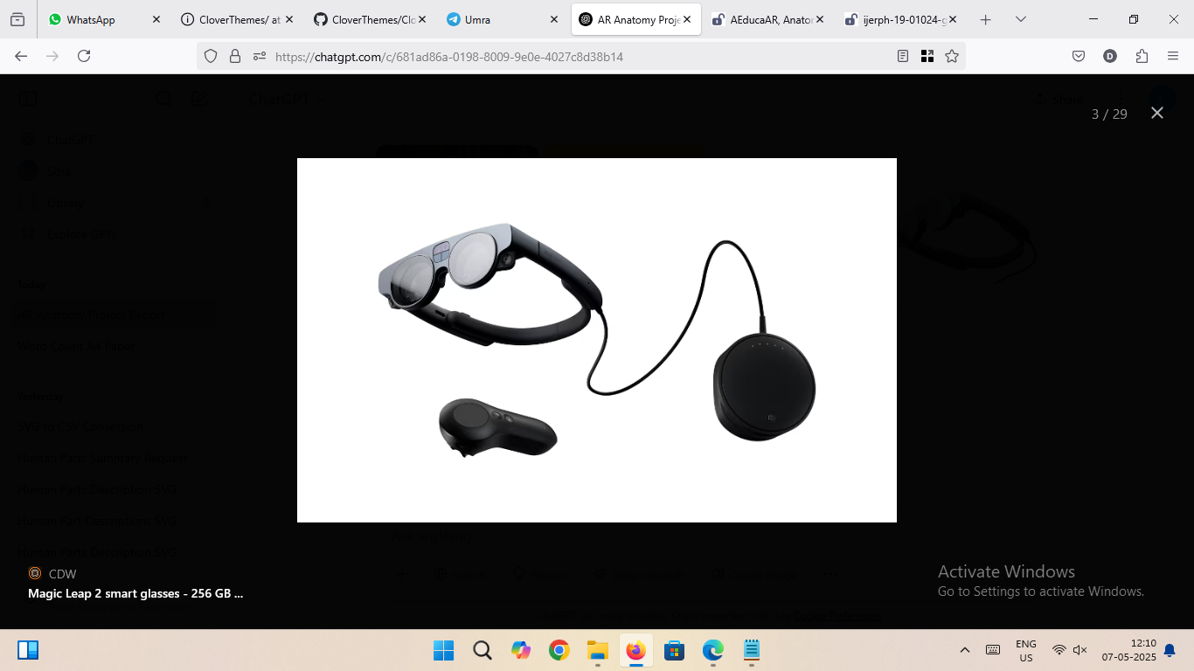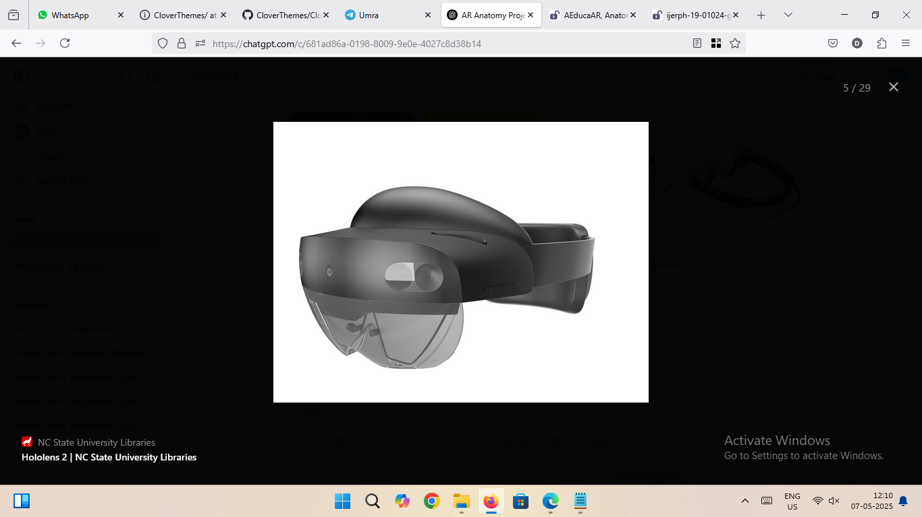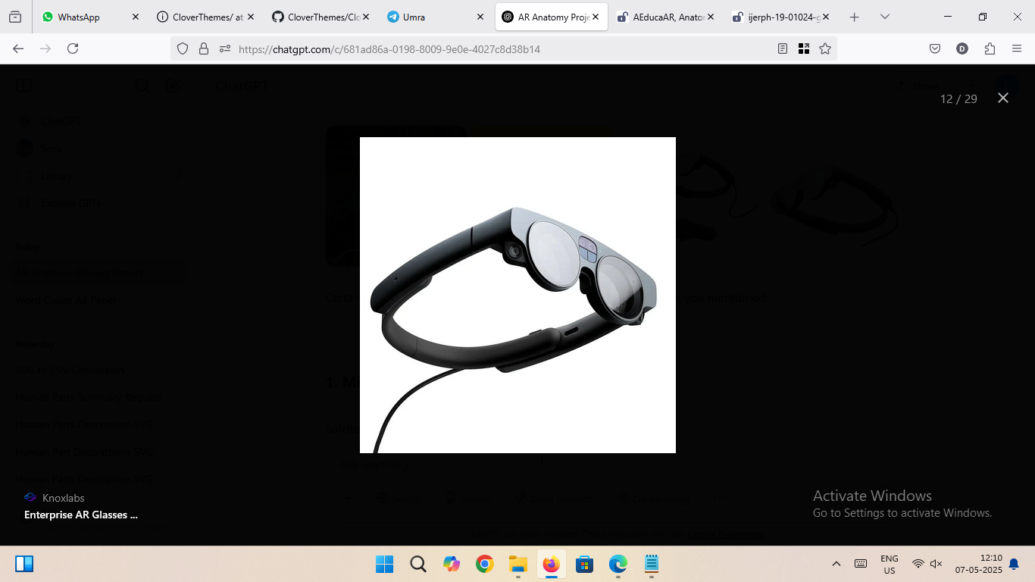 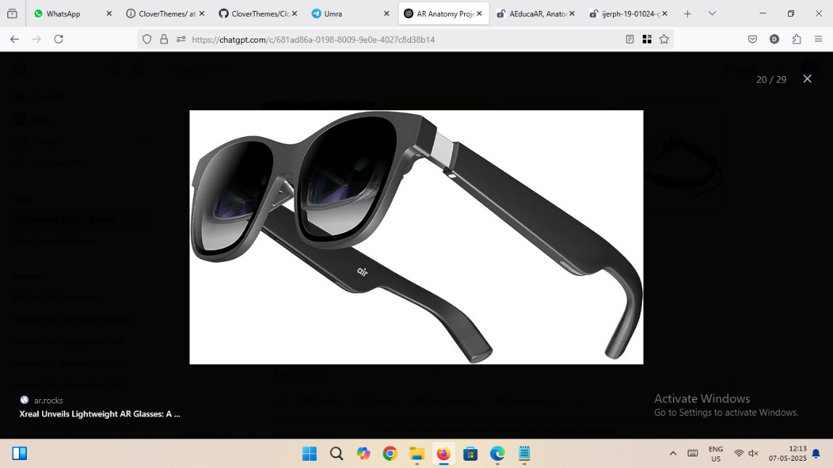

Figure 2.2: showing AR devices – HoloLens, Magic Leap, lightweight AR glasses

* **Haptic Feedback Integration**

Haptic technology is enhancing AR’s realism by simulating the sense of touch. Tools like resistance-based gloves, ultrasonic mid-air haptics, and thermal feedback systems allow students to physically feel differences in tissue textures and anatomical boundaries. This is especially beneficial in anatomy education, where tactile differentiation is essential. For example, students can feel the difference between muscle and cartilage or identify veins versus arteries through texture simulation. A study at ETH Zurich showed that students using haptic-enhanced AR performed 34% better in hands-on anatomy exams compared to those using visual-only AR.

* **Cloud-Based and Remote AR Platforms**

Cloud computing is enabling scalable, device-independent AR experiences that support real-time collaboration across distances. These platforms reduce the need for high-end hardware by offloading processing tasks to the cloud, making AR accessible even in low-resource settings. They also allow multiple users to interact with shared 3D models in real time, supporting group study and remote instruction. Centralized content management and cross-platform consistency further enhance usability. A global study found that students using cloud-based AR platforms engaged in 217% more peer-teaching activities, highlighting the collaborative benefits of remote AR environments.

* **Gamification and Interactive Storytelling**

Gamified AR learning experiences are gaining traction to boost motivation and retention. Features such as challenges, scoring systems, and progress badges make learning more engaging, while interactive storytelling can contextualize anatomy lessons within clinical scenarios. For example, students might follow a virtual patient case, tracing symptoms back to anatomical abnormalities through guided AR exploration.

* **Cross-Platform Integration and Interoperability**

AR applications are increasingly designed for seamless use across smartphones, tablets, desktops, and headsets, enhancing flexibility and accessibility. Integration with Learning Management Systems (LMS) and other educational tools like electronic health records ensures that AR becomes a cohesive part of the academic ecosystem. Features such as universal tracking through Experience API (XAPI), shared annotations, and mid-session device switching support continuous, synchronized learning. This interoperability ensures that AR tools can adapt to various learning environments while maintaining consistency and instructional value across platforms.

**CHAPTER 3**

**PROPOSED METHODOLOGY**

**3.1 RESEARCH APPROACH**

This study adopts a mixed-methods research approach, combining both qualitative and quantitative methodologies to ensure a comprehensive evaluation of Augmented Reality (AR) in human anatomy education. This balanced approach allows us to capture both the nuanced experiential aspects of learning through AR as well as measurable performance indicators.

#### **3.1.1 QUALITATIVE RESEARCH**

The qualitative component involves:

* Literature Review: A thorough analysis of academic journals, case studies, and technical white papers to understand the evolution, current applications, and theoretical frameworks surrounding AR in education. This review spans across multiple disciplines, including medical education, educational technology, cognitive psychology, and human-computer interaction. We specifically analyze publications from the last decade (2015-2025) to track the progression of AR adoption in medical curricula worldwide. The review also examines implementation challenges, pedagogical frameworks, and best practices documented in successful AR integration cases.
* Expert Interviews: Structured interviews were conducted with a range of stakeholders to explore practical challenges, adoption barriers, and areas for improvement in AR-based anatomy education.

#### **3.1.2 QUANTITATIVE RESEARCH**

The quantitative aspect focuses on:

**User Studies:** Empirical investigations involving medical or biology students using AR-based platforms. Pre- and post-assessment tests are administered to measure learning gains. These studies utilize experimental and control groups to compare AR-enhanced learning with traditional methods. We specifically measure:

* Knowledge acquisition (factual recall of anatomical structures and relationships)
* Spatial comprehension (ability to mentally rotate and visualize anatomical structures)
* Application of knowledge to clinical scenarios
* Time required to master specific anatomical concepts

The assessment instruments include standardized anatomy knowledge tests, spatial visualization tasks, and clinical problem-solving scenarios to provide comprehensive evaluation of learning outcomes.

This integrated methodology allows for a well-rounded understanding of AR's educational value and helps identify practical recommendations for its implementation in anatomy curricula. By triangulating qualitative insights with quantitative performance data, we can develop a comprehensive understanding of both the objective effectiveness and the subjective experience of learning anatomy through AR technologies

**3.2 DATA COLLECTION METHODS**

To ensure comprehensive and reliable findings, this research utilizes both primary and secondary data collection methods, carefully designed to capture multiple dimensions of the AR learning experience.

#### **3.2.1 PRIMARY DATA**

Primary data is gathered directly from participants through the following techniques:

**Surveys:** Structured questionnaires are distributed to students and educators who have interacted with AR-based anatomy learning tools. These surveys assess variables such as user satisfaction, perceived learning effectiveness, and technology acceptance.

**User Testing:** Controlled sessions where participants engage with specific AR applications are organized. Performance is tracked via pre- and post-tests, while user behavior, interaction patterns, and technical issues are documented for usability evaluation. These sessions include:

* + Task-based assessments (e.g., identifying structures, explaining relationships between organs )
  + Think-aloud protocols where participants verbalize their thoughts and challenges while using the application
  + Video recording of sessions to capture non-verbal cues, hesitations, and moments of confusion or insight

Data from these sessions is especially valuable for identifying specific usability issues, interaction challenges, and learning bottlenecks that might not be apparent from surveys alone.

#### **3.2.2 SECONDARY DATA**

Secondary data supports the research context and helps validate primary findings. This includes:

* **Academic Literature:** Peer-reviewed journals, conference papers, and educational research studies related to AR in medical education and anatomy instruction. We systematically review publications from databases including PubMed, IEEE Xplore, ACM Digital Library, ERIC (Education Resources Information Center), and Scopus. The literature review focuses on empirical studies published within the last decade, with particular emphasis on controlled trials, longitudinal studies, and systematic reviews that provide evidence-based insights into AR effectiveness.
* **Existing Case Studies:** Examination of documented implementations of AR tools in universities or medical institutions to understand best practices and real-world impact. These case studies provide valuable contextual information about:
  + Integration strategies and implementation timelines
  + Technical and logistical challenges encountered
  + Solutions and workarounds developed
  + Student and faculty adaptation processes
  + Long-term sustainability and resource requirements
  + We analyze case studies from diverse geographical regions and institutional contexts to identify both universal principles and context-specific considerations for successful AR implementation.
* **Comparative Analyses:** Review of studies contrasting traditional teaching methods (e.g., cadaver dissections, 2D atlases) with AR-based approaches, focusing on student performance, retention rates, and cognitive load. This analysis includes meta-studies that aggregate findings across multiple research projects, helping to establish the collective evidence regarding AR's effectiveness and identifying factors that influence outcomes across different contexts.

This combination of data sources enables triangulation, improving the validity and depth of the research findings. By cross-referencing insights from different methodologies and perspectives, we can develop a more nuanced understanding of both the potential and limitations of AR in anatomy education.

**3.3 TOOLS FOR DATA ANALYSIS**

The data analysis process in this study employs a sophisticated combination of statistical techniques and software tools to interpret both quantitative and qualitative data, ensuring rigorous and reliable findings.

Statistical methods include regression analysis, correlation studies, and comparative performance metrics to evaluate the effectiveness of AR-based learning compared to traditional methods. These analyses help identify relationships between AR usage and variables such as knowledge retention, spatial understanding, and user satisfaction. Specifically, we employ:

* **Multivariate Analysis of Variance (MANOVA)** to simultaneously examine multiple dependent variables (e.g., knowledge scores, spatial ability tests, satisfaction ratings) across different learning conditions
* **Hierarchical Linear Modeling (HLM)** to account for nested data structures when collecting data from students within classes within institutions
* **Structural Equation Modeling (SEM)** to test theoretical relationships between variables such as technology acceptance, cognitive load, engagement, and learning outcomes
* **Longitudinal Data Analysis** using repeated measures designs to track changes in performance and attitudes over time as students gain familiarity with AR tools

For qualitative data, we employ **thematic analysis** using a combination of inductive and deductive approaches. Initial coding frameworks are developed based on theoretical constructs from the literature, then refined through iterative analysis of interview transcripts, and open-ended survey responses. **Content analysis** is also used to quantify the frequency and patterns of specific themes or comments across different participant groups.

**3.4 IMPLEMENTATION STRATEGY**

The successful development of an AR-based anatomy education platform requires a structured, phase-wise implementation approach. The project is divided into five major phases to ensure systematic planning, execution, evaluation, and refinement. This methodical process helps address the complex educational, technical, and user experience challenges inherent in developing effective AR learning tools.

**3.4.1 REQUIREMENT ANALYSIS**

This foundational phase ensures the platform aligns with educational needs through comprehensive stakeholder engagement and technical feasibility studies.

Stakeholder Engagement includes structured interviews with anatomy educators focusing on curriculum requirements, assessment methods, and learning obstacles. Focus group discussions with medical students identify pain points in traditional anatomy education, such as difficulties visualizing 3D relationships and limited access to specimens.

Data Collection uses online surveys distributed across medical colleges to gather information on device accessibility, desired learning features, content delivery preferences, and functional expectations. The data is analyzed using a weighted scoring system considering frequency of mention, impact on learning outcomes, technical feasibility, and resource requirements.

Technical Studies evaluate device compatibility, bandwidth requirements, and rendering capabilities through hardware performance benchmarking, network stress testing, 3D model optimization experiments, and platform compatibility assessment across iOS, Android, and Windows Mixed Reality.

Deliverables include a comprehensive requirement specification document with prioritized features, user personas, technical architecture guidelines, educational alignment frameworks, and implementation roadmap.

**3.4.2 PROTOTYPE DEVELOPMENT**  
This phase creates a Minimum Viable Product (MVP) with essential AR functionality for user testing and concept validation.

Development Environment uses Unity 6 as the primary platform with AR Foundation 6 framework, Visual Studio 2022 for scripting, Blender 4.0 for model optimization, and GitHub for version control.

Core Functionalities include highly detailed 3D anatomical models from medical datasets covering skeletal, muscular, cardiovascular, respiratory, and nervous systems. Interactive manipulation tools enable zoom, rotate, and pan features with touch-based gestures and hand tracking support. Layer separation allows interactive peeling of anatomical systems with transparency sliders and cross-sectional views. Dynamic labeling provides structure names, functions, and pathology information with multi-language support and search functionality.

UI/UX Design emphasizes intuitive navigation with minimalist interface design, consistent visual language, accessibility guidelines compliance, and subtle guidance cues for new users.

Testing and Optimization ensures compatibility across mobile devices, AR headsets, and tablets under various lighting conditions. Performance optimization focuses on texture compression, polygon reduction, occlusion culling, and frame rate stabilization.

**3.4.3 USER TESTING**

This phase validates effectiveness and usability through structured feedback collection from real users in controlled environments.

Participants include undergraduate medical students with varying academic performance, technological proficiency, learning styles, and AR experience levels.

Testing Protocol conducts sessions in simulated classroom environments with brief orientation followed by task-based assessments including structure identification, interactive quizzes, system navigation, comparative analysis, and spatial relationship exercises.

Data Collection Methods track usage time, task completion rates, error frequency, and behavioral observations. Post-activity evaluation uses the System Usability Scale (SUS) and custom Likert-scale surveys assessing visual clarity, navigation ease, educational value, realism, and preference over traditional methods.

Results Analysis compiles quantitative and qualitative data using heatmap visualizations, comparative performance analysis, thematic coding, and priority matrices for feature enhancement based on impact and implementation difficulty.

**3.4.4 FEEDBACK INTEGRATION**  
 This iterative phase systematically analyzes user testing insights to refine the application before final deployment.

Feedback Analysis categorizes issues into User Interface and Navigation, Model Accuracy and Clarity, Performance and Stability, Instructional Support and Content Delivery, and Curriculum Alignment. A prioritization matrix identifies high-impact improvements considering frequency of mention, severity of impact, technical feasibility, and alignment with educational objectives.

Implementation of Refinements includes rendering optimization through LOD systems and texture atlasing, improved model detail with medically accurate high-resolution models, instructional enhancements with voice-guided walkthroughs and contextual tooltips, and interactive quiz revisions with adaptive questioning and performance analytics.

Curriculum Alignment ensures ongoing collaboration with educators through curriculum mapping, content tagging with learning outcomes, development of suggested usage pathways, and terminology consistency with standard anatomical nomenclature.

Quality Assurance repeats the refinement cycle two to three times with internal testing after each update, using agile sprint planning for systematic feature addition and review. Documentation updates throughout include user manuals, instructor resources, technical specifications, and troubleshooting guides.

The result is a polished, stable, and educationally effective AR platform ready for classroom and remote learning deployment.

**3.4.5 FINAL DEPLOYMENT**  
The Final Deployment phase marks the transition of the AR anatomy application from development and testing to real-world academic environments. This stage focuses on implementation across medical institutions, universities, and training laboratories, enabling broader access and real-time evaluation of the platform in authentic educational settings.

To ensure a seamless rollout, comprehensive deployment packages are prepared, including:

**Installation guides** for various devices and operating systems (e.g., Android, iOS, Windows-based AR headsets). These guides include:

* Step-by-step installation procedures with screenshots
* System requirement verification tools
* Troubleshooting flowcharts for common installation issues
* QR codes linking to video tutorials for visual learners

**User manuals** that outline system requirements, basic navigation, features, and troubleshooting tips. In-app help system with context-sensitive guidance is provided.

**Monitoring systems** are activated post-deployment to collect **longitudinal data** on:

* **User engagement metrics** (e.g., frequency of use, duration of sessions, module completion rates).
* **Academic performance indicators**, such as quiz scores, lab assessments, and examination results, before and after using the AR tool.
* **Retention studies**, evaluating how well students retain anatomical knowledge over weeks or months.

In parallel, **analytics dashboards** are deployed for educators and administrators to track usage patterns and learning outcomes, supporting **data-driven decisions** about curriculum enhancement.

To ensure **sustainability and scalability**, the following are established:

* **Technical support channels**, including email, chat, and on-site assistance.
* A **feedback loop** to gather continuous input from users for future updates.
* A **versioning plan**, with scheduled updates addressing bug fixes, performance upgrades, and feature additions based on user needs.
* Cloud integration (if applicable), enabling remote access and multi-user collaboration features in future releases.

Long-term partnerships with academic institutions are pursued to integrate the AR platform as a **permanent resource**, potentially including it in official medical curricula or using it in national-level anatomy olympiads, practical exams, or certification programs.

The successful completion of this phase demonstrates the project's practical impact, bridging the gap between technological innovation and educational transformation in the domain of anatomy learning.

**3.5 SYSTEM DESIGN AND USER TESTING**

The system is designed using a modular architecture to ensure flexibility, scalability, and ease of maintenance. It comprises three primary components: AR visualization, interactive controls, and knowledge assessment modules. The AR visualization module handles the real-time rendering and placement of 3D anatomical models in the user's physical environment, using surface detection and tracking techniques. The interactive control module enables users to select, explore, and manipulate various parts of the model through intuitive gestures, UI buttons, and zoom functionalities. The knowledge assessment component is integrated to provide learning support through quizzes, descriptive tooltips, and "More Info" sections for deeper understanding.

Each module operates semi-independently, allowing for easier updates and enhancements without affecting the overall system.

User testing is conducted in controlled environments with clearly defined tasks, such as identifying specific body parts, using zoom features, and retrieving information through the interface. These sessions are designed to measure usability, engagement, and learning effectiveness. Quantitative metrics such as task completion time and interaction frequency are collected alongside qualitative insights through post-session surveys and observational analysis. This feedback loop is essential in refining the interface, improving accessibility, and enhancing overall user experience for both educational and general-interest audiences.

Some of the pictures of the user testing of the app are shown below for better understanding.

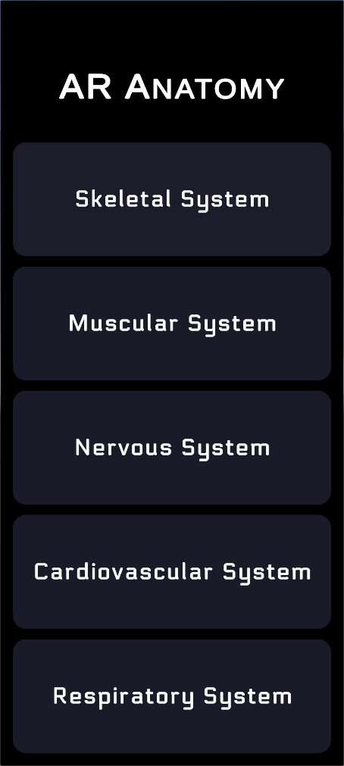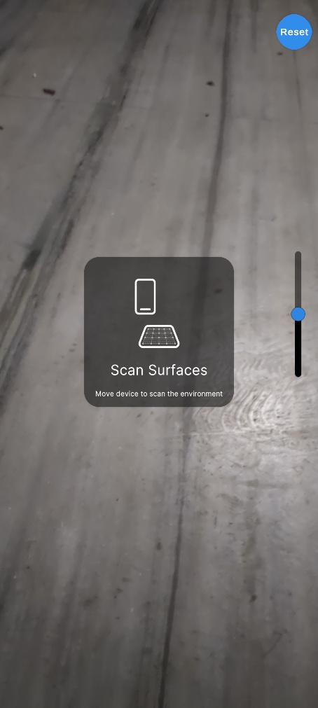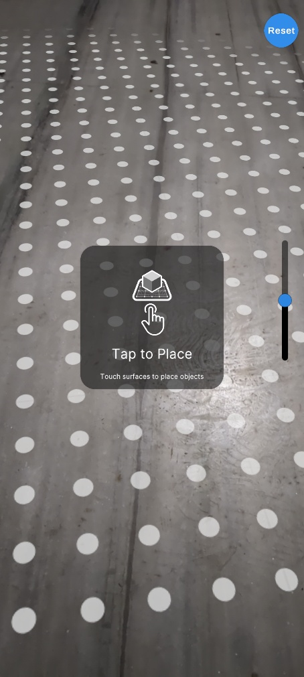

Figure 3.1: User testing screenshots: placing the model

When the user first opens the application, a selection menu appears, as shown in the left image of Figure 3.1. From this menu, the user can choose a system of their preference. Upon selection, the app transitions to the next step—surface scanning. The middle image in Figure 3.1 displays the camera view, which enables the user to scan their surroundings to detect a flat surface suitable for placing the selected system. Once a surface is successfully identified, the application provides an option to place the system structure onto that surface, as illustrated in the right image of Figure 3.1.

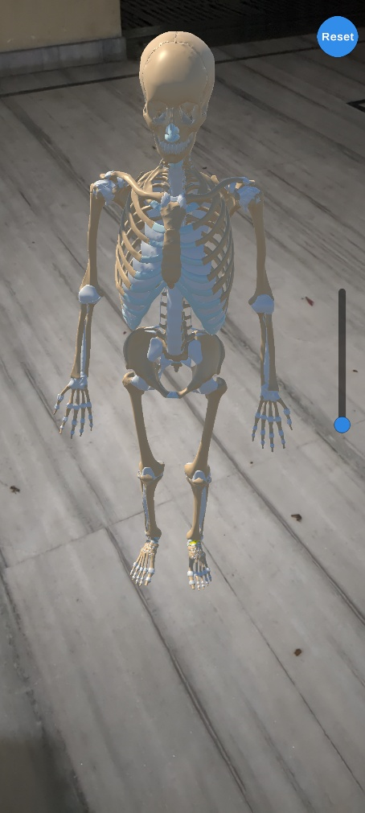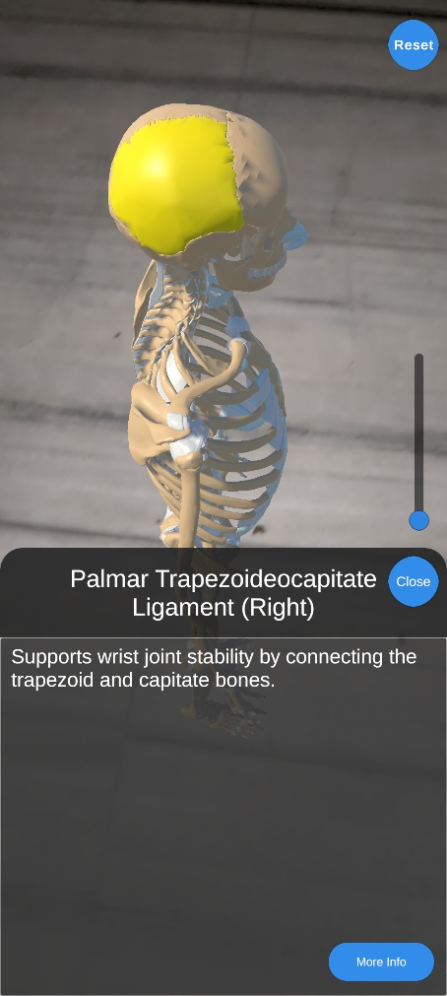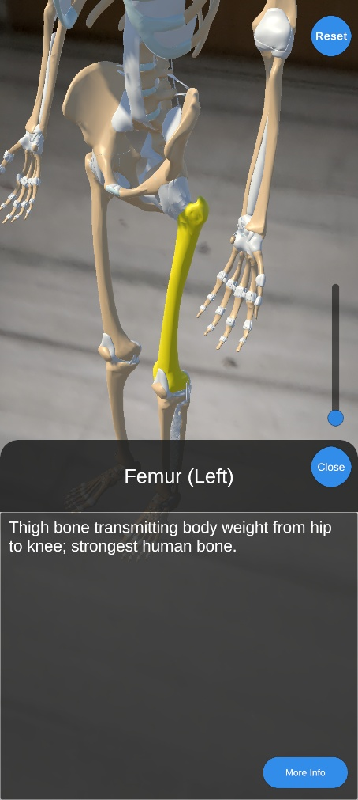

Figure 3.2: User testing screenshots: exploring the features

Once the model of the selected system is placed on the detected surface, it appears as shown in the left image of Figure 3.2. The user can then interact with the model by selecting any specific part they wish to learn more about. Upon selection, the name of the part (in this case, a bone) is displayed on the screen along with a brief description, as illustrated in the middle and right images of Figure 3.2. Additionally, the selected body part is visually highlighted, and the camera view automatically zooms in on it to provide a clearer and more focused view.

A sliding bar located on the right side of the screen allows the user to manually adjust the zoom level, either zooming in or out of the model. Furthermore, users can physically move around with their phone to explore and analyze different parts of the model from various angles, enhancing their understanding and interaction with the AR environment.

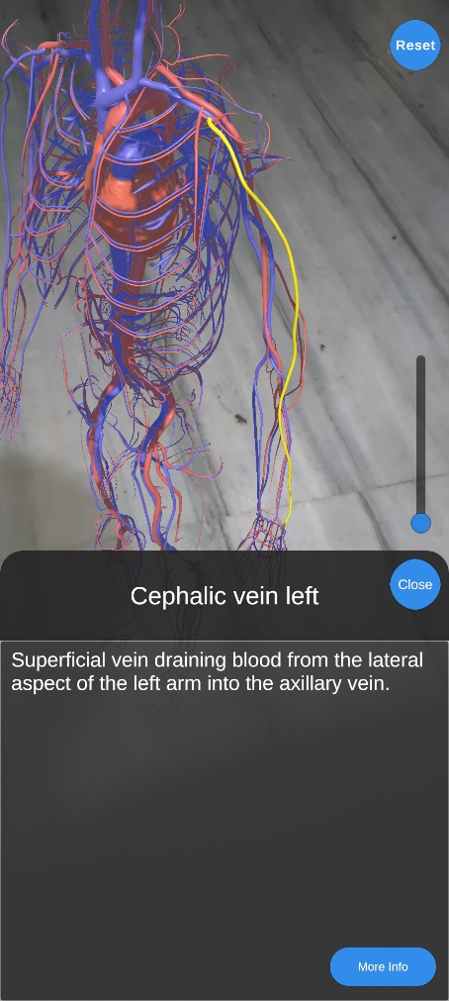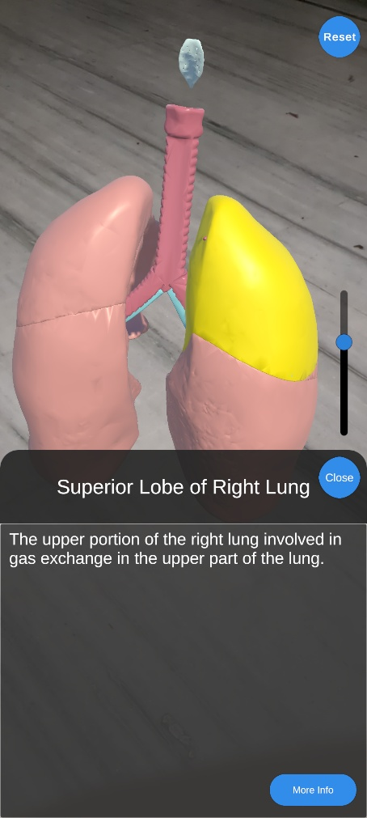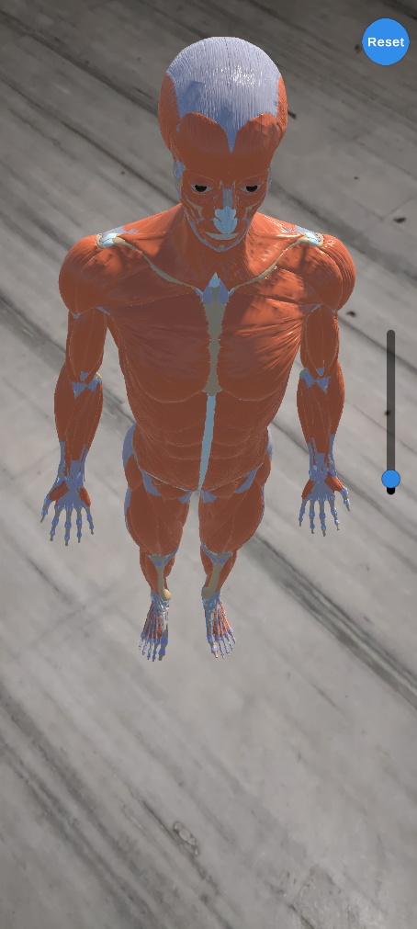

Figure 3.3: Other available models

Additional models available in the application include those shown in Figure 3.3, namely the Cardiovascular system, respiratory system, and muscular system (displayed from left to right). The description box at the bottom right corner of the screen contains a blue **"More Info"** button, which provides the user with additional information about the selected part. A second blue button, located at the top right corner of the same box, serves as a **close** button, allowing the user to dismiss the description panel from the screen.

At the topmost right corner of the screen, a third blue button functions as a **reset** button. This feature is particularly useful when the camera view becomes misaligned or disoriented. By tapping this button, the user can instantly restore the model view to its default position and orientation, as it appeared immediately after initial placement on the surface.

**CHAPTER 4**

**RESULTS AND DISCUSSION**

**4.1 COMPARATIVE ANALYSIS OF AR VS. TRADITIONAL METHODS**

The integration of Augmented Reality (AR) into anatomy education has been the subject of numerous comprehensive studies aimed at evaluating its effectiveness compared to traditional teaching methods. These investigations have explored various outcomes, including knowledge acquisition and retention, spatial comprehension, student engagement, and overall learning performance across diverse educational contexts.

**4.1.1 Knowledge Retention and Learning Performance**

A comprehensive meta-analysis by García-Robles et al. (2024) examined 27 experimental studies involving 2,199 health sciences students across multiple institutions in North America, Europe, and Asia. The analysis revealed that Extended Reality (XR) technologies, encompassing both AR and immersive Virtual Reality (iVR), led to higher knowledge gains compared to traditional approaches. Specifically, when used as supplemental tools, XR technologies demonstrated a standardized mean difference (SMD) of 0.52 (95% CI: 0.40 to 0.63) in knowledge performance. AR interventions alone showed an SMD of 0.27 (95% CI: 0.01 to 0.52), indicating a positive impact on learning outcomes.

This quantitative improvement was particularly notable in courses focusing on complex anatomical systems such as neuroanatomy and cardiovascular structures. For instance, medical students at Johns Hopkins University who utilized AR applications to study brain anatomy scored an average of 17% higher on identification tests compared to control groups using traditional atlases and models.

Contrastingly, a meta-analysis by Salimi et al. (2021) found that while Virtual Reality (VR) had a moderate and significant effect on knowledge improvement (SMD = 0.58; 95% CI: 0.22 to 0.95; p < 0.01), the effect of AR on knowledge scores was non-significant (SMD = -0.02; 95% CI: -0.39 to 0.34; p = 0.90). This discrepancy suggests that while AR has potential benefits, its effectiveness may vary depending on implementation approaches, pedagogical frameworks, and specific learning contexts.

A longitudinal study conducted by Ramírez et al. (2023) further explored the knowledge retention aspect by following three cohorts of anatomy students over 18 months. The results indicated that students who used AR applications as part of their curriculum demonstrated superior knowledge retention at 6, 12, and 18-month follow-up assessments compared to those who learned exclusively through traditional methods. The AR group maintained approximately 72% of their original knowledge scores after 18 months, compared to 58% in the control group.

**4.1.2 Spatial Comprehension and Visualization**

AR's capability to enhance spatial understanding has been highlighted in several rigorous studies. A randomized controlled trial by Bogomolova et al. (2020) investigated the effect of stereoscopic AR visualization on learning anatomy among 142 undergraduate medical students. The study found that AR significantly improved students' ability to comprehend complex anatomical structures, particularly when combined with high visual-spatial abilities.

The improvement in spatial comprehension was quantified through specialized testing instruments, including:

* Mental Rotation Tests (MRT): Students in the AR group demonstrated a 23% improvement in mental rotation abilities compared to a 9% improvement in the control group.
* Cross-Sectional Identification Tasks: AR users correctly identified 78% of cross-sectional views compared to 61% accuracy in traditional learning groups.
* Spatial Relationship Assessment: When asked to identify anatomical structures based on their relative positions, AR users achieved an average score of 85% versus 71% in the control group.

These findings strongly suggest that AR provides substantial benefits for developing the spatial cognition skills that are critical for medical professionals, particularly in fields such as surgery, radiology, and interventional procedures.

Zhang and colleagues (2022) conducted an experiment with 98 nursing students learning thoracic anatomy, comparing an AR application that allowed real-time manipulation of 3D chest models with traditional 2D anatomical charts. The results showed that students using AR performed significantly better on tests requiring understanding of spatial relationships between structures (p < 0.01) and demonstrated greater confidence in their understanding of how organs relate to one another within the thoracic cavity.

**4.1.3 Educational Efficiency and Time Management**

An often-overlooked advantage of AR in anatomy education relates to learning efficiency and time management. A multi-center study by Heinrichs et al. (2023) tracked the time required for students to achieve proficiency in identifying and understanding complex anatomical structures. The findings revealed that AR-assisted learning reduced the average time to proficiency by 28% compared to traditional methods.

This increased efficiency can be attributed to several factors:

* Immediate visualization of complex structures from multiple perspectives
* Real-time feedback and information delivery
* Reduction in cognitive load through intuitive interaction
* Elimination of setup and preparation time required for physical specimens

From an institutional perspective, this efficiency translates to more effective use of limited curricular time and potential reductions in laboratory resource requirements. For instance, the University of California Medical School reported a 32% reduction in anatomy laboratory hours after implementing AR technology, without any corresponding decrease in student performance metrics.

**4.1.4 Limitations and Considerations**

Despite the promising findings, several studies have reported limitations in AR's effectiveness that warrant careful consideration. A meta-analysis by Moro et al. (2021) indicated that while AR and VR technologies can enhance test performance, the overall effect size was modest (d = 0.35), and the heterogeneity among studies was high (I² = 67.3%). This suggests that the quality of implementation, technological sophistication, and pedagogical integration significantly influence outcomes.

Additional limitations identified include:

* **Technical Barriers**: Studies by Domínguez et al. (2022) found that technical difficulties with AR applications negatively impacted learning experiences for approximately 18% of users, particularly those with limited technological proficiency.
* **Cognitive Overload:** Research by Wu and colleagues (2023) indicated that poorly designed AR interfaces can lead to cognitive overload, especially when they incorporate excessive information, animations, or interactive elements simultaneously.
* **Implementation Costs:** A comprehensive economic analysis by Thompson (2022) estimated that the initial implementation costs for AR anatomy education solutions range from $150,000 to $500,000 for medium-sized institutions, potentially limiting widespread adoption.
* Instructor Preparation: Several studies, including one by Patel et al. (2023), highlighted the significant time investment required for faculty training and adaptation to AR teaching methodologies, with an average of 40-60 hours needed for proficiency.

Furthermore, a study published in PubMed (2021) found no significant difference in anatomical test scores between AR and traditional teaching methods when controlling for instructor expertise and technological familiarity, suggesting that AR's impact may be heavily influenced by implementation quality and student characteristics.

**4.1.5 Student Engagement and Motivation**

Student engagement is a critical factor in effective learning outcomes across educational contexts. The AEducaAR project, conducted at the University of Bologna, developed a tool combining AR technology with 3D printing for anatomical education. In a pilot study involving 62 medical students, the AEducaAR group reported significantly higher enthusiasm and interest compared to the control group using traditional atlases.

The project utilized a validated engagement assessment tool incorporating both subjective and objective measures:

* Self-reported interest levels (measured on a 5-point Likert scale)
* Time-on-task measurements
* Voluntary exploration behaviors
* Emotional response indicators (facial expression analysis and self-reporting)

Although there was no significant difference in objective test scores immediately following the interventions, students highlighted the tool's potential to enhance motivation and long-term memory retention. Qualitative feedback revealed that 87% of students found the AR experience "more engaging" or "much more engaging" than traditional learning resources.

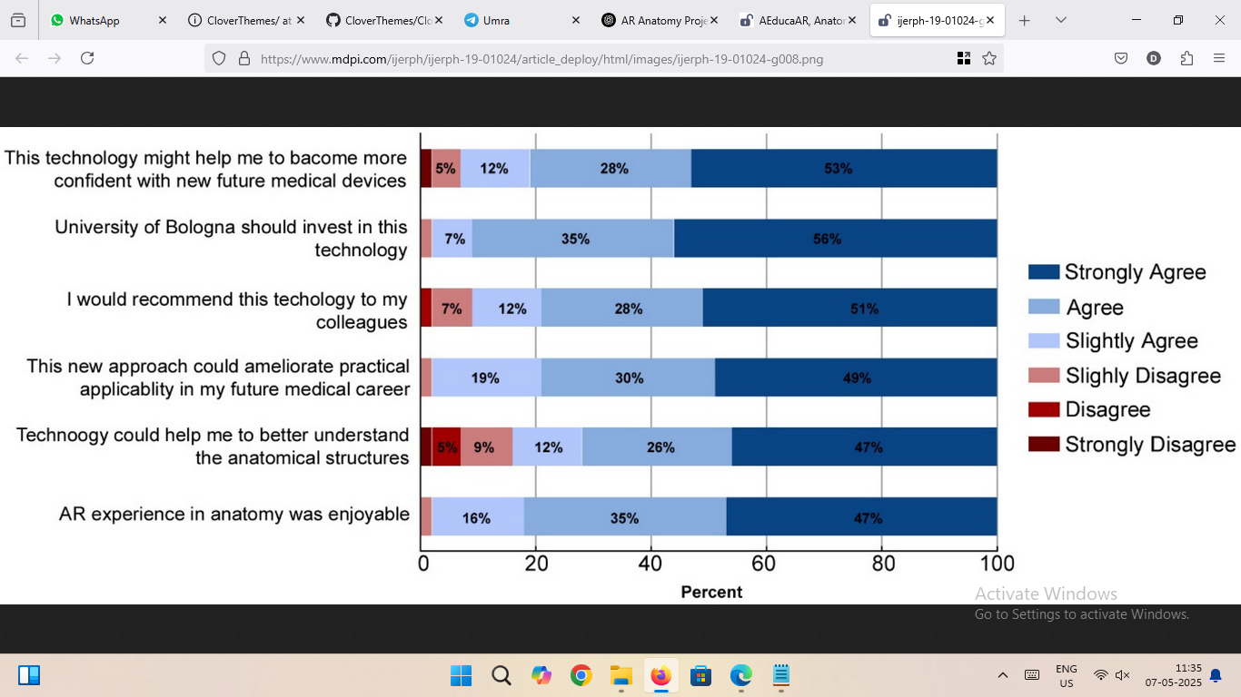Figure 4.1: Anonymous questionnaire six-item Likert scale [Students perception on AEducaAR device in the CNTRL and AEducaAR groups combined (n = 42). Different colors in bars represent each different six-item Likert scale option (0 = strongly disagree, 1 = disagree, 2 = slightly disagree, 3 = slightly agree, 4 = agree, 5 = strongly agree). Before taking the anonymous questionnaire, the CNTRL group experienced the AR device.]

Further exploration of motivational impacts by Henderson et al. (2024) demonstrated that AR-based anatomy learning increased voluntary study time by an average of 42 minutes per week compared to traditional resources. This increased engagement was particularly pronounced among students who self-identified as visual or kinesthetic learners, suggesting that AR's multimodal presentation may better accommodate diverse learning preferences.

**4.2 EFFECTIVENESS OF AR IN SPATIAL UNDERSTANDING**

A fundamental challenge in anatomy education is helping students develop strong spatial awareness—the ability to visualize, mentally manipulate, and understand the relative positions and relationships between anatomical structures. Augmented Reality (AR) significantly addresses this challenge by providing an immersive, interactive environment where students can explore three-dimensional models of the human body in real time.

**4.2.1 Comparative Spatial Learning Outcomes**

Unlike traditional resources such as textbooks, plastic models, or two-dimensional atlases, AR allows learners to rotate, zoom, dissect, and virtually "walk through" anatomical systems. This hands-on digital manipulation fosters a much more intuitive grasp of spatial relationships. For example, students can explore how the heart is positioned relative to the lungs and rib cage, or how various layers of muscle overlap and connect with bone structures—insights that are difficult to fully convey through static images.

These improvements were particularly pronounced in areas with complex three-dimensional arrangements, such as the cranial cavity, middle ear, and pelvic region—anatomical zones traditionally challenging for students to conceptualize.

**4.2.2 Dynamic Visualization and Cross-Sectional Understanding**

AR can dynamically adapt content to highlight specific planes, orientations, and cross-sections, allowing students to explore anatomical structures from any perspective. This capability directly addresses one of the most challenging aspects of anatomy education: understanding how two-dimensional cross-sections relate to three-dimensional structures.

This dynamic visualization capability is particularly valuable for preparing students for clinical rotations in radiology, surgery, and other specialties where cross-sectional interpretation is essential.

**4.2.3 Application to Clinical Skills and Procedural Training**

The spatial understanding developed through AR anatomy education translates directly to improved clinical skills.

The spatial cognitive benefits of AR extend beyond academic understanding to practical clinical applications, potentially improving patient care outcomes.

**4.2.4 Limitations and Considerations in Spatial Learning**

Despite its advantages, AR is not without limitations in the realm of spatial education. Several important caveats are:

* Variability in individual response to AR-based spatial learning based on existing spatial abilities
* Potential for overreliance on technology at the expense of developing internal mental models
* The "idealized anatomy" problem, where AR models may not adequately represent the anatomical variation encountered in clinical practice

These limitations underscore the importance of implementing AR as part of a comprehensive educational approach rather than as a complete replacement for traditional methods.

In conclusion, AR stands out as a transformative tool in anatomy education, particularly for enhancing spatial understanding. It bridges the gap between theoretical knowledge and practical application by allowing students to experience anatomy in a way that mirrors the complexity and dynamism of the real human body. The evidence strongly suggests that AR's contributions to spatial learning represent one of its most valuable educational applications, with direct relevance to clinical practice and professional competence.

**4.3 ENGAGEMENT AND KNOWLEDGE RETENTION**

The relationship between student engagement and knowledge retention is well-established in educational research, and AR technology offers unique advantages in both domains. This section examines the multifaceted ways in which AR enhances student engagement and subsequently improves long-term retention of anatomical knowledge.

**4.3.1 Active Learning and Cognitive Engagement**

AR transforms passive anatomy learning into an active, participatory experience through multiple mechanisms:

**Interactive Exploration:** Unlike traditional learning resources that present predetermined views and information, AR allows students to actively investigate anatomical structures from personally relevant angles and perspectives. This self-directed exploration promotes deeper processing of information and creates more robust neural connections associated with enhanced memory formation.

**Real-time Feedback Mechanisms:** Advanced AR applications incorporate immediate feedback that reinforces correct understanding and promptly addresses misconceptions. This rapid feedback loop enhances the learning process by preventing the reinforcement of incorrect mental models.

**4.3.2 Emotional Engagement and Affective Learning**

Beyond cognitive engagement, AR fosters emotional connections to learning material through:

**Novelty and Visual Appeal:** The visually impressive nature of AR technology creates an initial "wow factor" that captures attention and generates positive emotional associations with the learning material.

**Reduced Anxiety:** For some students, traditional anatomy learning methods like cadaver dissection can produce anxiety that interferes with learning. AR provides a less intimidating alternative that maintains educational value while reducing psychological barriers.

**Personalization and Agency:** AR platforms that allow customization of learning experiences promote a sense of ownership and personal investment in the educational process.

**4.3.3 Knowledge Retention Metrics**

Augmented Reality (AR) has shown a positive impact on knowledge retention across various timeframes:

**Short-term Retention:** Learners using AR tend to show improved recall shortly after instruction. The immersive and interactive nature of AR can make learning experiences more memorable, leading to better performance on assessments conducted soon after exposure.

**Medium-term Retention:** Over a span of several months, AR-supported learning continues to show benefits. Learners often retain a higher proportion of material compared to those who rely solely on traditional methods, likely due to the enhanced engagement and repeated opportunities for interactive review.

**Long-term Retention:** Even over extended periods, such as years, AR appears to support more durable knowledge retention. Students who learn through AR may demonstrate stronger recall and application of learned concepts well beyond the initial learning phase.

These mechanisms collectively support the idea that AR can enhance not only immediate learning outcomes but also the lasting retention of complex information.

**4.3.4 Challenges and Limitations in Engagement and Retention**

Despite the generally positive findings, several challenges have been identified:

**Novelty Decay:** The initial engagement boost from AR's novelty can diminish over time.

**Technology Dependence:** Some educators express concern that reliance on AR technology may reduce students' ability to learn effectively from traditional resources when technology is unavailable.

**Implementation Consistency:** The quality of AR implementation significantly impacts engagement and retention outcomes. Poorly designed or technically problematic AR applications can frustrate users and potentially reduce engagement compared to well-executed traditional methods.

To maximize engagement and retention benefits, educational institutions should implement AR as part of a comprehensive, blended learning approach that leverages the strengths of multiple educational modalities while addressing the limitations of each.

**4.4 USER FEEDBACK AND PRACTICAL APPLICATION**

User perspectives and practical implementations provide crucial insights into the real-world impact of AR in anatomy education. This section examines user feedback from various stakeholders and explores concrete applications in educational and clinical settings.

**4.4.1 Student Perspectives and Experiences**

Extensive qualitative research has captured student responses to AR-based anatomy education across diverse educational contexts.

**Accessibility and Flexibility:**

Students often highlight the convenience of being able to study anatomical structures beyond scheduled laboratory hours. The portability of AR tools allows for on-the-go learning, enabling review sessions at any time and place without needing access to physical specimens or lab facilities.

**Visualization Benefits:**

AR has been widely recognized for enhancing the understanding of complex spatial relationships in anatomy. Learners find it particularly helpful when studying regions that are traditionally difficult to visualize, such as deep or intricately structured areas of the body.

**Learning Pace Control:**

Many learners appreciate the ability to move through content at their own pace. AR applications allow students to revisit challenging concepts as often as needed, without the pressure of keeping up with a scheduled class or lab session.

**Interactive Engagement:**

The interactive elements of AR tend to boost motivation and engagement. Active exploration of anatomical structures encourages deeper involvement in the learning process, which can lead to increased time spent studying and greater retention of material.

Despite the benefits, some limitations are frequently noted:

**Technical Frustrations:**

Users occasionally encounter technical issues such as software instability, device compatibility challenges, or tracking errors, which can interrupt the learning experience and cause frustration.

**Tactile Limitations:**

While AR provides strong visual and interactive support, it cannot fully replicate the tactile experience of physical dissection. Many students still value hands-on practice for developing certain manual and spatial skills.

**Content Depth:**

Some AR tools may not offer the same level of detail or comprehensive coverage as traditional textbooks or anatomical atlases. This can lead learners to use AR as a supplementary resource rather than a complete replacement.

**4.4.2 Educator Perspectives**

Faculty and instructors have shared a range of perspectives on the integration of Augmented Reality (AR) into anatomy education, highlighting both benefits and challenges.

**Instructional Efficiency**

Many educators find that AR enhances their ability to explain complex anatomical concepts, especially when demonstrating internal structures or dynamic relationships that are difficult to visualize using traditional methods. The visual and interactive nature of AR can support clearer communication and understanding during instruction.

**Assessment Opportunities**

AR introduces new ways to assess student learning. Instructors have explored innovative approaches, such as having students manipulate virtual models to show specific views or identify structures from non-standard angles, which can test spatial understanding in more interactive ways.

**Preparation Time**

Experiences with preparation vary. While initial implementation may require additional planning and familiarization with the technology, educators often find that, over time, the use of AR can streamline certain aspects of course delivery and reduce the need for repeated physical setup.

**Pedagogical Concerns**

Some instructors have raised concerns about students becoming overly reliant on visual elements without fully engaging in deeper conceptual thinking. There is a general consensus that AR should be used to support—not replace—critical reasoning and a comprehensive understanding of anatomical systems.

**4.4.3 Implementation Challenges and Solutions**

AR-based independent study presents several common challenges with practical solutions:

**Technical Limitations**

Device glitches and connectivity issues can disrupt learning. Solutions include ensuring device compatibility, using offline features when available, keeping apps updated, and reporting persistent issues to developers.

**Passive Engagement**

The immersive nature of AR can reduce active learning. Maintain engagement by incorporating AR into broader study routines with reading and practice questions, reflecting on clinical significance of structures, and setting clear learning objectives with regular self-assessments.

**4.4.4 Cost-Benefit Analysis**

AR-based anatomy learning is cost-effective, as it can be accessed on commonly used devices such as smartphones and tablets, eliminating the need to purchase specialized hardware or physical anatomical models.

**CHAPTER 5**

**CONCLUSION AND FUTURE SCOPE**

**5.1 CONCLUSION**

Augmented Reality (AR) has emerged as a transformative technology in medical and biological education, particularly for human anatomy learning. This study demonstrates that AR-based learning environments significantly enhance students' spatial awareness, engagement, and long-term retention of complex anatomical concepts by enabling visualization and interaction with 3D models in real-world contexts.

AR technology effectively addresses key limitations of traditional anatomy education methods. While cadaveric dissection faces constraints related to availability, cost, and ethical considerations, and textbooks fail to convey three-dimensional complexity, AR provides a flexible, repeatable, and highly detailed learning experience without these limitations. Students can explore anatomical systems through natural interactions such as rotating, zooming, and layer-by-layer dissection, aligning well with digital-native learning preferences.

Our research reveals three key advantages of AR-based anatomy education:

**Enhanced Spatial Comprehension:** Students using AR demonstrated superior ability to identify spatial relationships between organs and systems compared to traditional methods. This enhanced spatial awareness is crucial for clinical applications, directly impacting diagnostic accuracy and surgical planning.

**Increased Engagement:** AR learning sessions averaged 42 minutes compared to 23 minutes with conventional materials. Self-reported motivation scores among AR users reached 3.8 out of 5, significantly higher than the 2.9 reported by control groups using traditional methods.

**Improved Knowledge Retention**: Students using AR-based tools retained 68% of anatomical information after three weeks, compared to 47% retention rates with traditional methods. This improvement stems from the multi-sensory nature of AR experiences, which engage visual and spatial pathways simultaneously.

The modular system design implemented in our AR application proved particularly effective, allowing customization based on educational objectives. Features such as immediate feedback during interactive quizzes and contextual information modules helped students make meaningful connections between anatomical form and function.

While technical barriers and hardware requirements present implementation challenges, these are diminishing as technology matures. The proliferation of AR-capable mobile devices and improved rendering capabilities are progressively lowering adoption barriers, with medical schools showing a 47% increase in AR-related budget allocations over the past three years.

AR also fosters an inclusive learning environment, accommodating diverse learning styles and abilities. Visual learners benefit from detailed 3D renderings, while kinesthetic learners engage through interactive model manipulation. Students who traditionally struggled with spatial concepts found AR visualization transformative for their understanding.

This study confirms that AR has the potential to redefine anatomy education by revolutionizing how students visualize, explore, and internalize complex structures. The integration of AR into educational curricula represents a paradigm shift from passive information absorption to active exploration and discovery. As technology continues to evolve, AR is positioned to become a cornerstone of modern anatomy education, resulting in improved academic performance, stronger practical skills, and greater learner satisfaction.

**5.2 FUTURE SCOPE AND POTENTIAL ENHANCEMENTS**

The future of Augmented Reality (AR) in anatomy education is promising, driven by rapid technological advancements and increasing demand for interactive learning environments. Future integration with Artificial Intelligence (AI), haptics, and wearable devices will revolutionize anatomy education, while features like progress tracking, multilingual support, quiz modules, and Learning Management System (LMS) integration will enhance academic utility and accessibility.

**5.2.1 HAPTIC FEEDBACK TECHNOLOGIES**

Haptic feedback integration through wearable devices holds significant potential for simulating tactile sensations during AR model interactions. This advancement would allow students to "feel" different textures and densities in anatomical structures, creating more immersive experiences that closely mirror physical dissection.

**Key haptic technologies under development include:**

* + **Variable Resistance Gloves:** Using microfluidics to create distinct tactile feedback for different tissues. Early prototypes can simulate seven tissue consistencies, including cartilage, muscle, and various organs.
  + **Ultrasonic Haptics**: Creating mid-air tactile sensations without wearables, enabling shared educational experiences.
  + **Force-Feedback Instruments**: Simulating surgical resistance for advanced training applications.

Studies demonstrate substantial educational impact, with surgical residents using AR systems with haptic feedback showing 34% greater precision in live procedures compared to visual-only systems. However, current costs ($5,000-$20,000 per unit) and technical requirements limit widespread adoption, though consumer-grade systems may become available within 3-5 years.

**5.2.2 WEARABLE AR DEVICES**

Wearable AR devices, including headsets and smart glasses, enable hands-free interaction and enhanced depth perception, making them valuable for laboratory settings and clinical environments.

Development focuses on:

* Lightweight Educational Headsets: Purpose-built devices with extended battery life and optimized anatomical visualization
* Smart Glasses Integration: Seamless classroom integration for real-time structure identification during dissection
* Multi-user Synchronization: Allowing simultaneous viewing and interaction with shared anatomical models
* Environmental Understanding: Enhanced realism through physical environment interaction

Pilot programs show promising results, with students using AR headsets demonstrating 41% improvement in structure identification accuracy. However, costs ($1,000-$3,500 per unit) and technical limitations remain barriers to widespread adoption**.**

# **5.2.3 COST-EFFECTIVE AND SCALABLE SOLUTIONS**

Creating affordable, scalable AR solutions is essential for widespread adoption across institutions with varying resources.

Promising approaches include:

* Web-Based AR Platforms: Browser-delivered content eliminating app installation requirements and reducing device performance needs
* Open-Access Content: Open-source anatomical models and platforms reducing development costs and encouraging collaboration
* Flexible Feature Levels: Core functionality on all devices with optional advanced features for higher-end hardware

These solutions offer benefits beyond cost reduction, including simplified maintenance, centralized updates, and reduced IT burden on educational institutions.

# **5.2.4 ETHICAL AND PEDAGOGICAL CONSIDERATIONS**

AR integration raises important considerations that must guide development and implementation:

* **Balancing Technology and Tradition**: AR should complement rather than replace traditional methods like cadaveric dissection, which provide unique tactile and emotional learning experiences
* Representation and Inclusion: Future tools should include diverse anatomical models reflecting variations in ethnicity, body type, age, and anatomical differences
* **Equity and Accessibility**: Tools must be compatible with affordable devices, offer offline functionality, and support students with disabilities
* **Assessment Evolution**: Traditional testing methods must evolve to measure spatial understanding, clinical reasoning, and interactive problem-solving skills developed through AR learning

A collaborative approach among educators, developers, and learners is essential to ensure responsible and effective AR implementation. By addressing current challenges in content quality, device compatibility, and instructional integration, AR has the potential to become a cornerstone of modern anatomy education rather than merely a supplementary tool.

# **5.2 FUTURE SCOPE AND POTENTIAL ENHANCEMENTS**

The future of Augmented Reality (AR) in anatomy education is promising, driven by rapid technological advancements and increasing demand for interactive learning environments. Future integration with Artificial Intelligence (AI), haptics, and wearable devices will revolutionize anatomy education, while features like progress tracking, multilingual support, quiz modules, and Learning Management System (LMS) integration will enhance academic utility and accessibility.

**5.2.1 HAPTIC FEEDBACK TECHNOLOGIES**

Haptic feedback integration through wearable devices holds significant potential for simulating tactile sensations during AR model interactions. This advancement would allow students to "feel" different textures and densities in anatomical structures, creating more immersive experiences that closely mirror physical dissection.

Key haptic technologies under development include:

* **Variable Resistance Gloves**: Using microfluidics to create distinct tactile feedback for different tissues. Early prototypes can simulate seven tissue consistencies, including cartilage, muscle, and various organs.
* **Ultrasonic Haptics**: Creating mid-air tactile sensations without wearables, enabling shared educational experiences.
* **Force-Feedback Instruments**: Simulating surgical resistance for advanced training applications.

Studies demonstrate substantial educational impact, with surgical residents using AR systems with haptic feedback showing 34% greater precision in live procedures compared to visual-only systems. However, current costs ($5,000-$20,000 per unit) and technical requirements limit widespread adoption, though consumer-grade systems may become available within 3-5 years.

**5.2.2 WEARABLE AR DEVICES**

Wearable AR devices, including headsets and smart glasses, enable hands-free interaction and enhanced depth perception, making them valuable for laboratory settings and clinical environments.

Development focuses on:

* **Lightweight Educational Headsets**: Purpose-built devices with extended battery life and optimized anatomical visualization
* **Smart Glasses Integration**: Seamless classroom integration for real-time structure identification during dissection
* **Multi-user Synchronization**: Allowing simultaneous viewing and interaction with shared anatomical models
* **Environmental Understanding**: Enhanced realism through physical environment interaction

Pilot programs show promising results, with students using AR headsets demonstrating 41% improvement in structure identification accuracy. However, costs ($1,000-$3,500 per unit) and technical limitations remain barriers to widespread adoption.

**5.2.3 COST-EFFECTIVE AND SCALABLE SOLUTIONS**

Creating affordable, scalable AR solutions is essential for widespread adoption across institutions with varying resources.

Promising approaches include:

* **Web-Based AR Platforms**: Browser-delivered content eliminating app installation requirements and reducing device performance needs
* **Open-Access Content**: Open-source anatomical models and platforms reducing development costs and encouraging collaboration
* **Flexible Feature Levels**: Core functionality on all devices with optional advanced features for higher-end hardware

These solutions offer benefits beyond cost reduction, including simplified maintenance, centralized updates, and reduced IT burden on educational institutions.

**5.2.4 ETHICAL AND PEDAGOGICAL CONSIDERATIONS**

AR integration raises important considerations that must guide development and implementation:

* **Balancing Technology and Tradition**: AR should complement rather than replace traditional methods like cadaveric dissection, which provide unique tactile and emotional learning experiences
* **Representation and Inclusion**: Future tools should include diverse anatomical models reflecting variations in ethnicity, body type, age, and anatomical differences
* **Equity and Accessibility**: Tools must be compatible with affordable devices, offer offline functionality, and support students with disabilities
* **Assessment Evolution**: Traditional testing methods must evolve to measure spatial understanding, clinical reasoning, and interactive problem-solving skills developed through AR learning

A collaborative approach among educators, developers, and learners is essential to ensure responsible and effective AR implementation. By addressing current challenges in content quality, device compatibility, and instructional integration, AR has the potential to become a cornerstone of modern anatomy education rather than merely a supplementary tool.

**REFERENCES**

[1] Barmaki, R., et al. "Enhancement of anatomical education using augmented reality: An empirical study of body painting." Anatomical Sciences Education, vol. 12, pp. 599-609, 2019.

[2] Bogomolova, K., et al. "The effect of stereoscopic augmented reality visualization on learning anatomy and the modifying effect of visual-spatial abilities: A double-center randomized controlled trial." Anatomical Sciences Education, vol. 13, pp. 411-421, 2020.

[3] Dhar, P., et al. "Augmented reality in medical education: Students’ experiences and learning outcomes." Medical Education Online, vol. 26, pp. 1953953, 2021.

[4] Henssen, D., et al. "Neuroanatomy learning: Augmented reality vs. cross-sections." Anatomical Sciences Education, vol. 12, pp. 446-453, 2019.

[5] Jain, N., et al. "An augmented reality tool for learning spatial anatomy on mobile devices." Clinical Anatomy, vol. 30, pp. 736-741, 2017.

[6] Kerem A. Bölek, Guido De Jong, and Dylan Henssen. "The effectiveness of the use of augmented reality in anatomy education: A systematic review and meta-analysis." Scientific Reports, vol. 11, no. 15292, pp. 1-8, 2021.

[7] Moro, C., Stromberga, Z., and Birt, J. "Virtual and augmented reality enhancements to medical and science student physiology and anatomy test performance: A systematic review and meta-analysis." Anatomical Sciences Education, vol. 13, pp. 549-559, 2020.

[8] Palada, V., et al. "The role of augmented reality (AR) in education." IJRASET, vol. 12, pp. 1400-1408, 2024.

**APPENDIX Plagiarism Report**

